This activity has been designed as a starting point for looking, talking and doing together. The Look and Think activities should take 5 -10 minutes.
The Do activities might take longer depending on the task and how creative you are feeling!
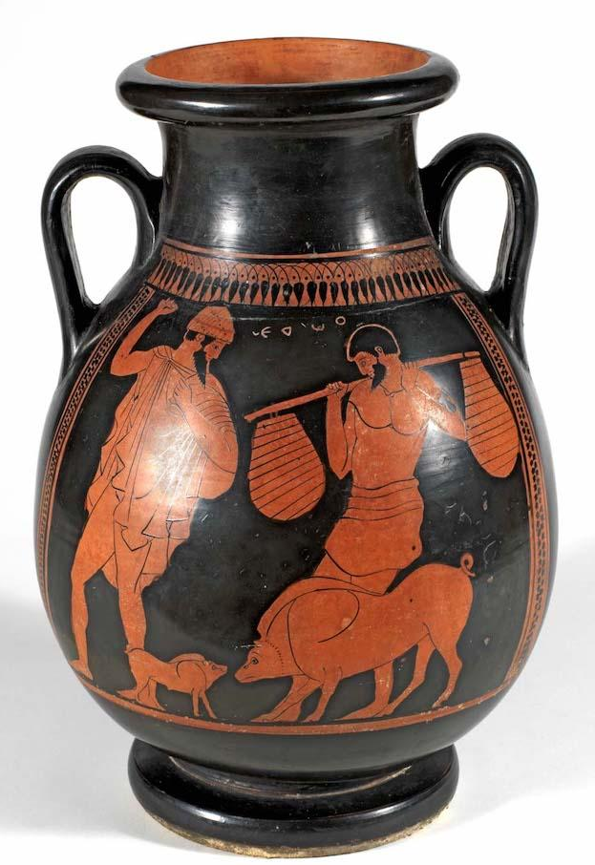
Think
Pots come in all different shapes and sizes!
What do you think this pot would have been used for and why? You can see pot types below.
Look
Take a close look at this pot. What can you see?
There are two main types of Greek painted pot. 'Black figure' which has black figures on a red background and 'red figure' which has red figures on a black background.
Which one do you think this is?

Two farmers with pigs
Red figure pelike
Do
Watch the video on our website to design your own ancient Greek pot or follow the steps below.

c. 470 BC
GR.9.1917

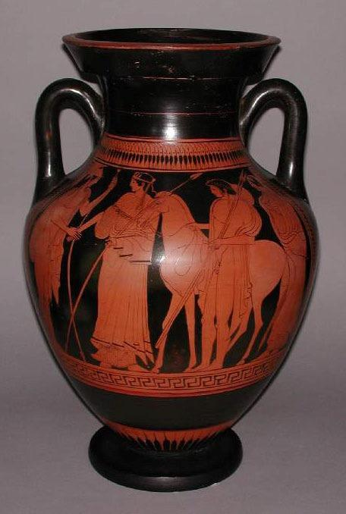
Children are often surprised at the large number of Greek pots on display in the Museum. There are various reasons why the culture of Ancient Greece is often well represented in museums by exhibitions of pottery. Clay was, and still is a readily available resource, that is easily worked into shapes and serves many basic functions. One reason that the Ancient Greeks made so many pots was that, as in most Ancient cultures, large numbers of pots were made to meet the everyday needs of containing and transporting goods.
Today these same functions are met in our society through the use of a wide variety of materials such as plastic and tin and the application of later technologies.

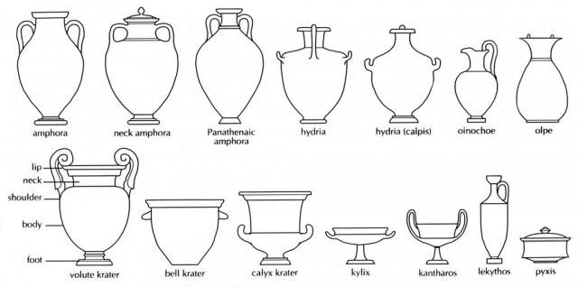
Red figure technique Wine-jar (amphora) showing warrior and youth with a horse
Case 6, Object 17, museum number GR.21.1937

Types of Pot

Do: Design your own ancient Greek pot
You will need  Paper  Pens  Wax candle or crayon  Black paint  Washing up liquid  Sharp tool for scraping e.g. a toothpick | Instructions  - Draw the outline of your pot. You can choose one of the shapes from this sheet.  - Draw around the outline in pen and then cover your pot with wax.  - Mix washing up liquid with black paint.  - Paint your pot and then let it dry.  - Use a sharp tool to scratch your design onto your pot. You can use patterns and pictures inspired by famous ancient Greek myths and legends

