This activity has been designed as a starting point for looking, talking and doing together. The Look and Think activities should take 5 -10 minutes.
The Do activities might take longer depending on the task and how creative you are feeling!
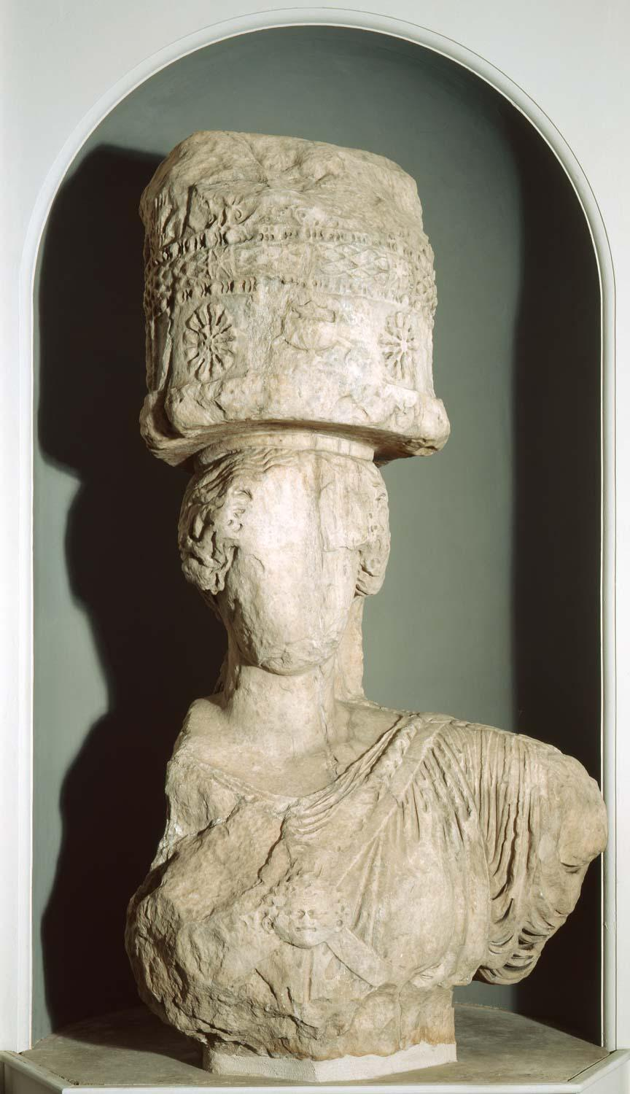
Think
When an English traveller saw this statue in 1801 in Greece, local people were still using it: making offerings of manure (a fertiliser) to help their crops to grow.
Clarke knew it was historic and took it back to England. Do you think this was fair?
Make a list of the pros and cons of the statue being in the museum.

Look
This enormous statue is over 2000 years old and used to be part of a temple to the Goddess Demeter.
Can you see how the statue might have changed over time?
Imagine what the statue would have looked like in the doorway of the original temple.

Upper part of a caryatid, from the Sanctuary
Do
Ancient Greek people loved to tell the stories of the Gods from memory.
Listen to the story of Demeter, or find a written version on the next page.
Who do you think the hero is? Who do you think the villain is?
Can you try and tell someone else the story of Demeter and Persephone?

of Demeter at Eleusis, near Athens.
Carved Pentelic marble.
Height 2.09 m, circa 50 B.C.
Find Spot: Eleusis; Inner Propylaea.
Production Place: Attica. Early Roman Period.

A caryatid is a sculpted female figure that acts as an architectural column. This is the upper part of one of a pair that flanked the gateway to the inner courtyard of the sanctuary of Demeter, Greek goddess of fertility. It was part of a building programme begun around 50 BC, by which time Greece was a Roman province. This Roman caryatid resembles the better-known Greek caryatids of the Erechtheion, a temple of the 5th century BC on the Athenian Acropolis. The deliberate reference to classical Athens, a city admired by the Romans, emphasises the connection between Athens and the sanctuary at Eleusis. The Eleusinian Mysteries, one of the most important of all Greek religious festivals, began with the worshippers walking the twelve miles from Athens to Eleusis. The festival was still important in the Roman period, and some Roman emperors were initiated into the cult. Since participants were sworn to secrecy, details of the ceremonies remain a mystery to this day, but they were connected with rituals of rebirth and the afterlife.
The caryatid was removed from Eleusis in 1801 by E.D. Clarke. The local people used to heap manure around it, believing it protected the fertility of their fields. Clarke identified it as Demeter, but it is more likely to represent a priestess. The figure is very worn, having stood for centuries above ground, but the gorgon head at her breast and the sacred container (cista) on her head are still visible. The second caryatid from the other side of the gateway is much better preserved. Excavated in the late 19th century, it is now in the Museum at Eleusis.
Do: The Story of Demeter and Persephone
Demeter was the ancient Greek goddess of the harvest. She was a very important goddess to ancient Greek people, who farmed a lot. Demeter had a kind and beautiful daughter, whose name was Persephone, and she loved her very much. Persephone, like her mum, loved nature.

One day she was walking in a beautiful meadow, gathering flowers, when a huge hole opened up in the ground. Hades, the god of the underworld, arrived and captured Persephone. He wanted the lovely Persephone to be his wife. How do you think she felt about that?

Demeter could no longer see her daughter, and she missed her hugely. She was so sad that it affected the harvest across Greece. Crops, fruit, and nature all stopped growing. So Demeter went to Zeus - the King of the gods - to ask him to help her get her daughter back. Zeus could see how Demeter's sadness was affecting Earth, and he agreed to help her.

Meanwhile, Hades wanted to make it difficult for Persephone to leave the underworld. He gave her some delicious underworld food: a pomegranate fruit. Zeus asked Hades to let the Persephone leave, but Hades said, "Only if she hasn't eaten any of the food that I've given her". But she already had. Persephone had eaten six pomegranate seeds!

Zeus and Hades agreed that Persephone would spend six months in the underworld, but that she could return to Earth for the other six months of the year: one month for every pomegranate seed. From then on, whenever Persephone was with Demeter on Earth, Demeter would be so happy that crops, fruit and plants would all grow beautifully. But, when Persephone went back to the underworld to live with Hades for six months, the plants stopped growing.

The ancient Greeks use this myth to explain something that affects how plants grow. What do you think it is?

