This activity has been designed as a starting point for looking, talking and doing together. The Look and Think activities should take 5 -10 minutes.
The Do activities might take longer depending on the task and how creative you are feeling!
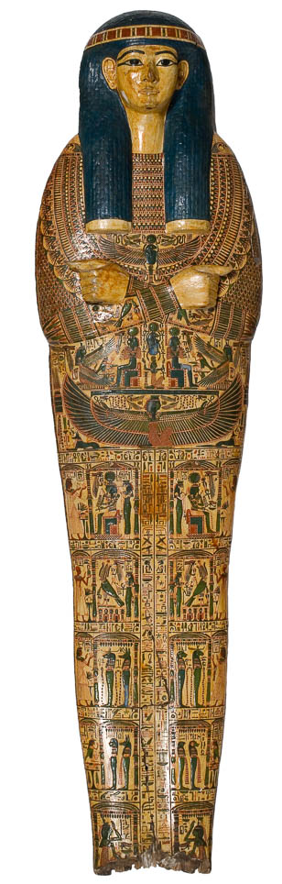
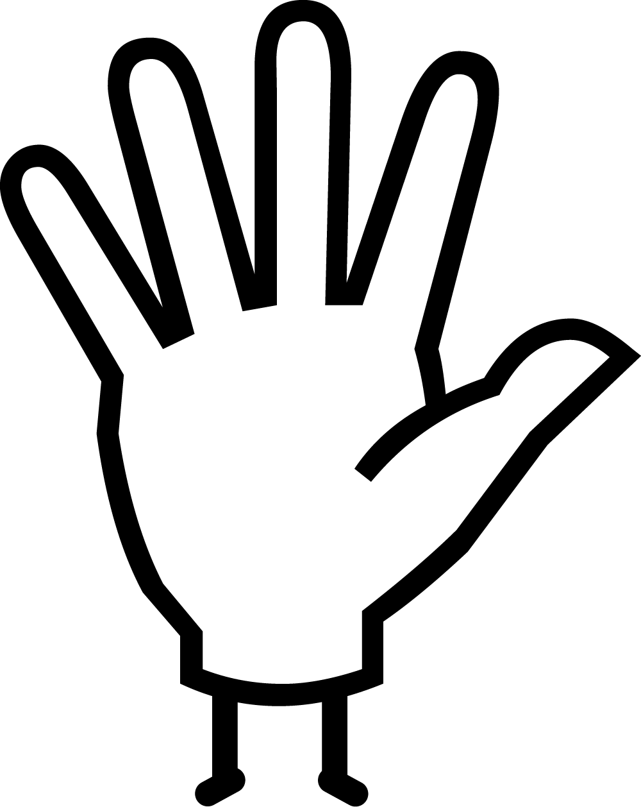Do
Recent research into these coffins has helped us to work out what tools the ancient Egyptians may have used. Make your own ancient Egyptian paintbrush:
You will need scissors and string.
- Wrap the string around your fingers many times, until you have covered half of your fingers.
- Take the string off you hand and keep it looped!
- Leaving 1cm at the top, tie the string around the loop.
- Wind the string around the loop, all the way along. Leave 1cm at the other end too.
- Tie the string and cut it.
- Cut through the sting at one of the ends that isn’t wrapped. These are the bristles.
- Your paintbrush is ready to go – give it a try!

Think
Nespawershefyt lived in Thebes, modern day Luxor, between 990 - 940 B.C. Can you work out how many years ago that was?
How do you think these wooden coffins survived for so many years without rotting?
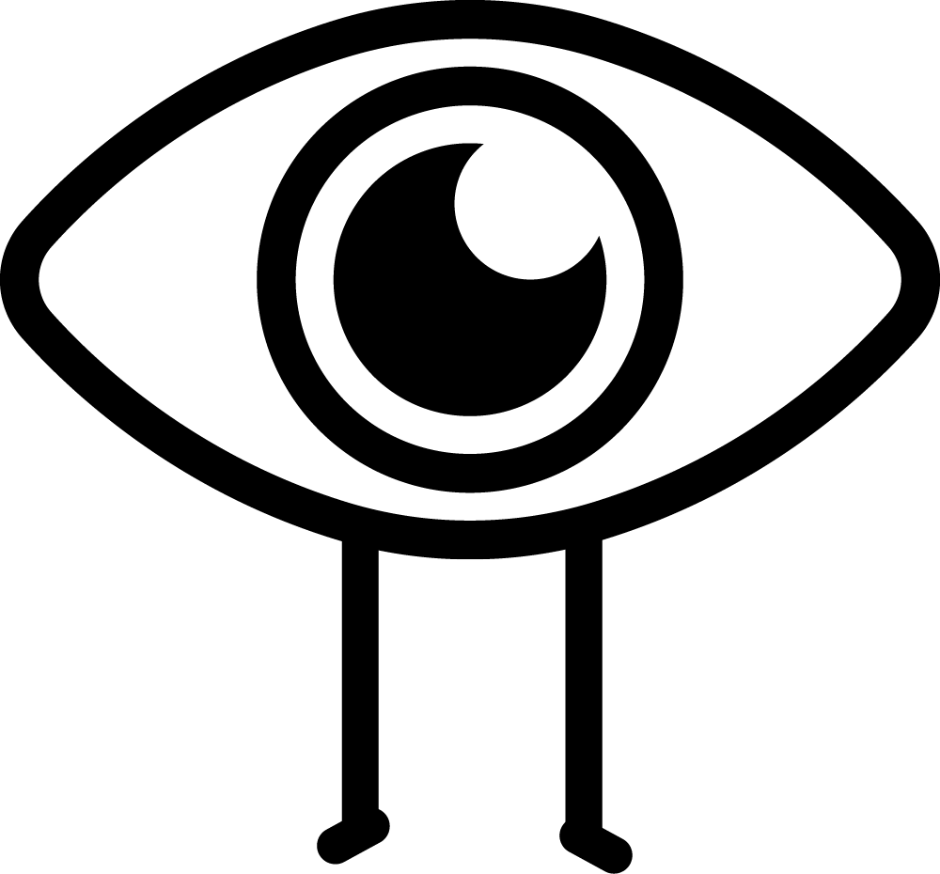Look
This coffin is covered in wonderful pictures of ancient Egyptian gods.
Can you see the goddess Nut, who was goddess of the sky, stars, and universe? She has enormous blue wings.
Mummy board from Nespawershefyt's
coffin set, unknown maker, c.1000 BC
E.1.1822
This mummy board is from the wooden anthropoid (human shaped) coffin set of Nespawershefyt (say Nes-pow-er-shef-eet). The set is comprised of a mummy board that would have laid over Nespawershefyt’s body, an inner coffin and an outer coffin. The two coffins both had a separate lid and box that would have all fitted together, one inside another. This was the first object acquired into The Fitzwilliam Museum’s ancient Egyptian collections. It was donated by two graduates of the University of Cambridge in 1822. Although we know they collected it whilst travelling, we do not know how they acquired the coffin set.
We know from the hieroglyphic inscriptions on this coffin set that Nespawershefyt was a high ranking official who worked at the temple of Karnak in ancient Thebes. His principal roles were ‘supervisor of craftsmen’s workshops’ in Karnak, and ‘supervisor of scribes’ in the temple of Amun. It is not surprising that someone high ranking within an arts and crafts profession has such a highly decorated coffin set. Presumably he could choose the best craftsmen for the job, and have a say over what would be included. The coffin set is densely decorated with religious scenes, including magical spells from the Book of the Dead. The text describes the types of offerings Nespawershefyt would receive in the afterlife, and spells to assure his safe passage to the netherworld. This panel shows Nespawershefyt kneeling down and offering his heart to be weighed by Anubis, the jackal headed god of mummification.
Since 2014, The Fitzwilliam Museum has been conducting cutting-edge interdisciplinary research into its collection of more than 200 ancient Egyptian coffins and coffin fragments. You can find out more about Nespawershefyt's coffin set on the Ancient Egyptian Coffins Project website.
How has Nespawershefyt’s wooden coffin survived so long without rotting?
Objects made of materials that would decay if you left them in the ground in the UK, such as wooden objects, do not usually rot in Egypt. This is because the rotting process is a result of the actions of bacteria or fungi, which need moisture to survive. The Egyptian climate is very dry, because Egypt has very little rainfall and lies at the very edge of the Sahara, one of the driest places on earth. Without the moisture, those bacteria or fungi are just not very active and so wooden objects are often amazingly well-preserved considering their age. This means that we have to be very careful about keeping them in a suitably dry environment here in the UK.
Story video: the Story of the Boat of Millions of Years
Do: Make your own paintbrush
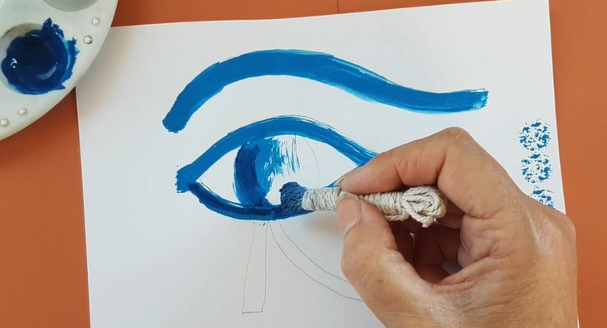Watch our how-to video

