This activity has been designed as a starting point for looking, talking and doing together. The Look and Think activities should take 5 -10 minutes.
The Do activities might take longer depending on the task and how creative you are feeling!
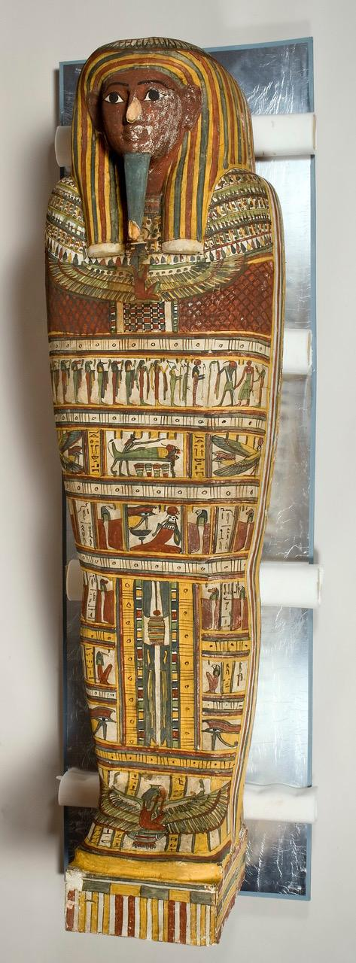
Do
See the next page for instructions how to make your own Egyptian neckpiece good enough to join Pakepu in the afterlife.
- Make a semi-circle out of card or a paper plate
- Decorate with shapes, pictures and patterns inspired by Pakepu’s coffin set
- Carefully make a hole on each side of the top edge
- Measure a piece of string or ribbon to tie it to your neck piece

Think
Look carefully at how the coffins have been painted and zoom in on some of the details.
Can you see anywhere that the artist has not been careful?
The blue in particular is very uneven.
Why do you think the blue paint might be different to the other colours? Find out on the next page.

Look
This coffin set has been decorated with ancient Egyptian gods, goddesses and hieroglyphic symbols.
Can you spot the figure of the jackal-headed god Anubis? He’s reaching a very long arm over Pakepu’s body!
Inner coffin lid from Papeku's coffin set,
unknown maker, about 680-665 BC
Outer coffin (2.10m long), inner coffin
(1.8m long), E.2.1869
According to Helen Strudwick, Associate Curator (Ancient Egypt), this wooden coffin set which belonged to a man called Pakepu, was made to fit one inside the other. They were presented as a gift to the Fitzwilliam Museum in 1869 by the future King Edward VII. They were said to come from Thebes, the ancient site at Luxor, which is about 450 miles south of Cairo.
Pakepu is described on his coffins as a “water pourer on the West of Thebes”. This means he was a person who could be employed by families to maintain the funerary cults of their dead relatives. He would have been expected to visit their tombs on the west bank of the Nile and perform rituals there, including pouring water for the dead. On the basis of the style of the coffin and its decoration, we believe Pakepu’s coffins were made about 680–665 BC. This would mean that he lived during a period when Egypt was ruled by Nubians from northern Sudan.
You can find out more about Pakepu’s coffin set on the Ancient Egyptian Coffins Project website.
Answers
- Can you spot the figure of the jackal-headed god Anubis?
Anubis was the god who looked after the dead. You can see him reaching (a very long arm) over Pakepu’s body in the centre of the coffin. Underneath him are 4 canopic jars, for storing his internal organs.
- Can you see anywhere the artist has not been careful? Why do you think the blue paint could be different to the other colours?
It could be because the artist isn’t very skilful, and that would suggest that the coffins were not “top of the range” but made more cheaply. All the paint is quite carelessly applied and the blue, in particular, is quite uneven. In comparison to the other colours, the blue is a man-made colour, known as “Egyptian blue”. It is made up of a ground up glass-like substance, which didn’t mix very well with the binder in the paint and so didn’t stick very well unless it was carefully applied.

