This activity has been designed as a starting point for looking, talking and doing together. The Look and Think activities should take 5 -10 minutes.
The Do activities might take longer depending on the task and how creative you are feeling!
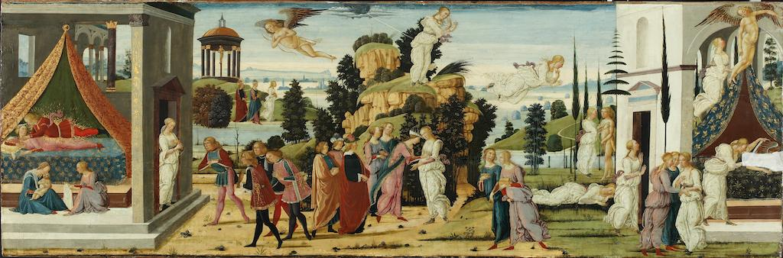
The story of Cupid and Psyche, Jacopo del Sellaio (1442 - 1493), c.1473
Tempera and gold on a wooden panel, M.75
Look
This painting tells the first half of an epic tale and is read from left to right like a cartoon strip.
Can you see who the main character is?
How many times can you see Psyche in her white dress?
Can you find Cupid? He has wings and a bow and arrow.

Think
Find out how to read the story visually below.
Before you find out, what do you think happens next?

Do
Write or draw your own ending to the story. Make a mini book using a piece of paper, scissors and a pencil, and then illustrate the ending of the story like a comic book.
- Fold your paper in half once, then again, and then again. When you open it up, your paper should show eight rectangles.
- Open it up and mark on the middle line at the first fold, using your pencil.
- Cut along the middle line across three pairs of rectangles to get to the pencil mark.
- Fold it in half again in the middle of the one pair of rectangles that is still connected.
- Fold the rest up into a concertina book. The middle pages will be joined together.

Jacopo del Sellaio was born and worked in Florence during the Renaissance, at a time when the city was emerging as the cultural and artistic centre of Europe. He was trained by the painter Fra Filippo Lippi and his style of painting uses a light palette of colours and experiments with linear perspective. He was influenced by the artist Sandro Botticelli who trained with him and their work is similar in style.
This colourful panel is from a 'spalliera', a decorated backboard. It would either be mounted on a wall as a headboard or attached to furniture, most commonly a ‘cassone’ (marriage chest). These special chests were made to celebrate a marriage, and were part of a bride’s dowry. They were filled with expensive linen and clothes and paraded through the streets from the bride’s family home to her new home as part of the wedding celebration. It would then be used as a piece of furniture in the family home for storage and sometimes as a bench to sit on.
In 2020, 3800 primary aged children from 40 schools across Cambridgeshire were inspired to create their own creative responses to Cupid and Psyche. You can find out more about the INSPIRE project, and see some of their beautiful artworks on our website.
How to read the panel painting:
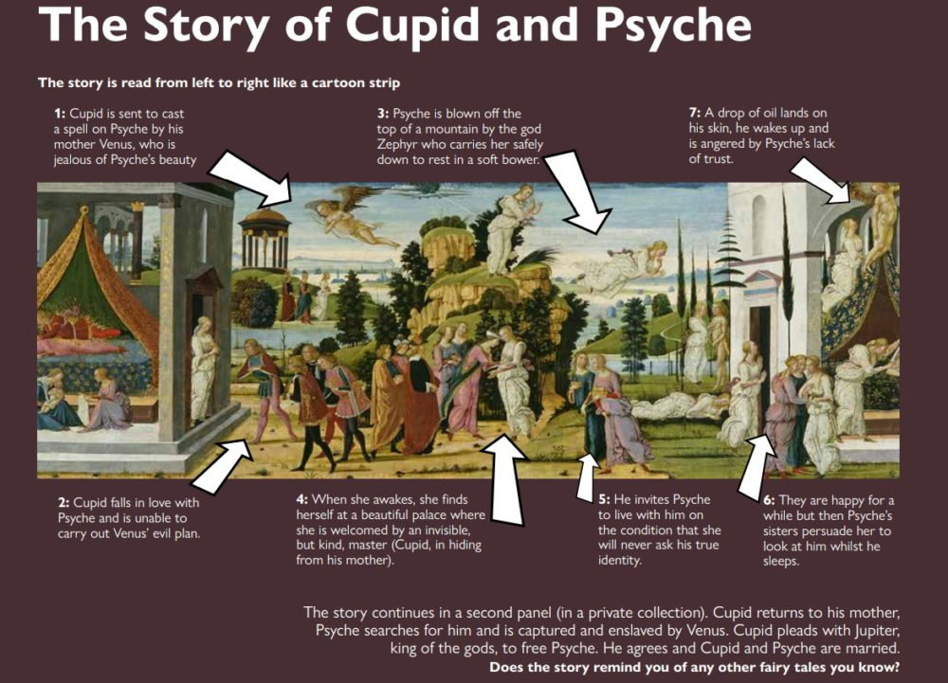 The story is read left to right like a cartoon strip. Fifteen episodes from the story appear across the panel. Many involve the same characters and all take place against a simple background and landscape. Psyche appears twelve times – eleven as a woman in a white dress and once as a baby. This method of visual storytelling is called ‘continuous narrative’. This might be confusing today when we are used to seeing single frames of action. However, this was a familiar way of telling stories in Renaissance Italy.

