This activity has been designed as a starting point for looking, talking and doing together. The Look and Think activities should take 5 -10 minutes.
The Do activities might take longer depending on the task and how creative you are feeling!
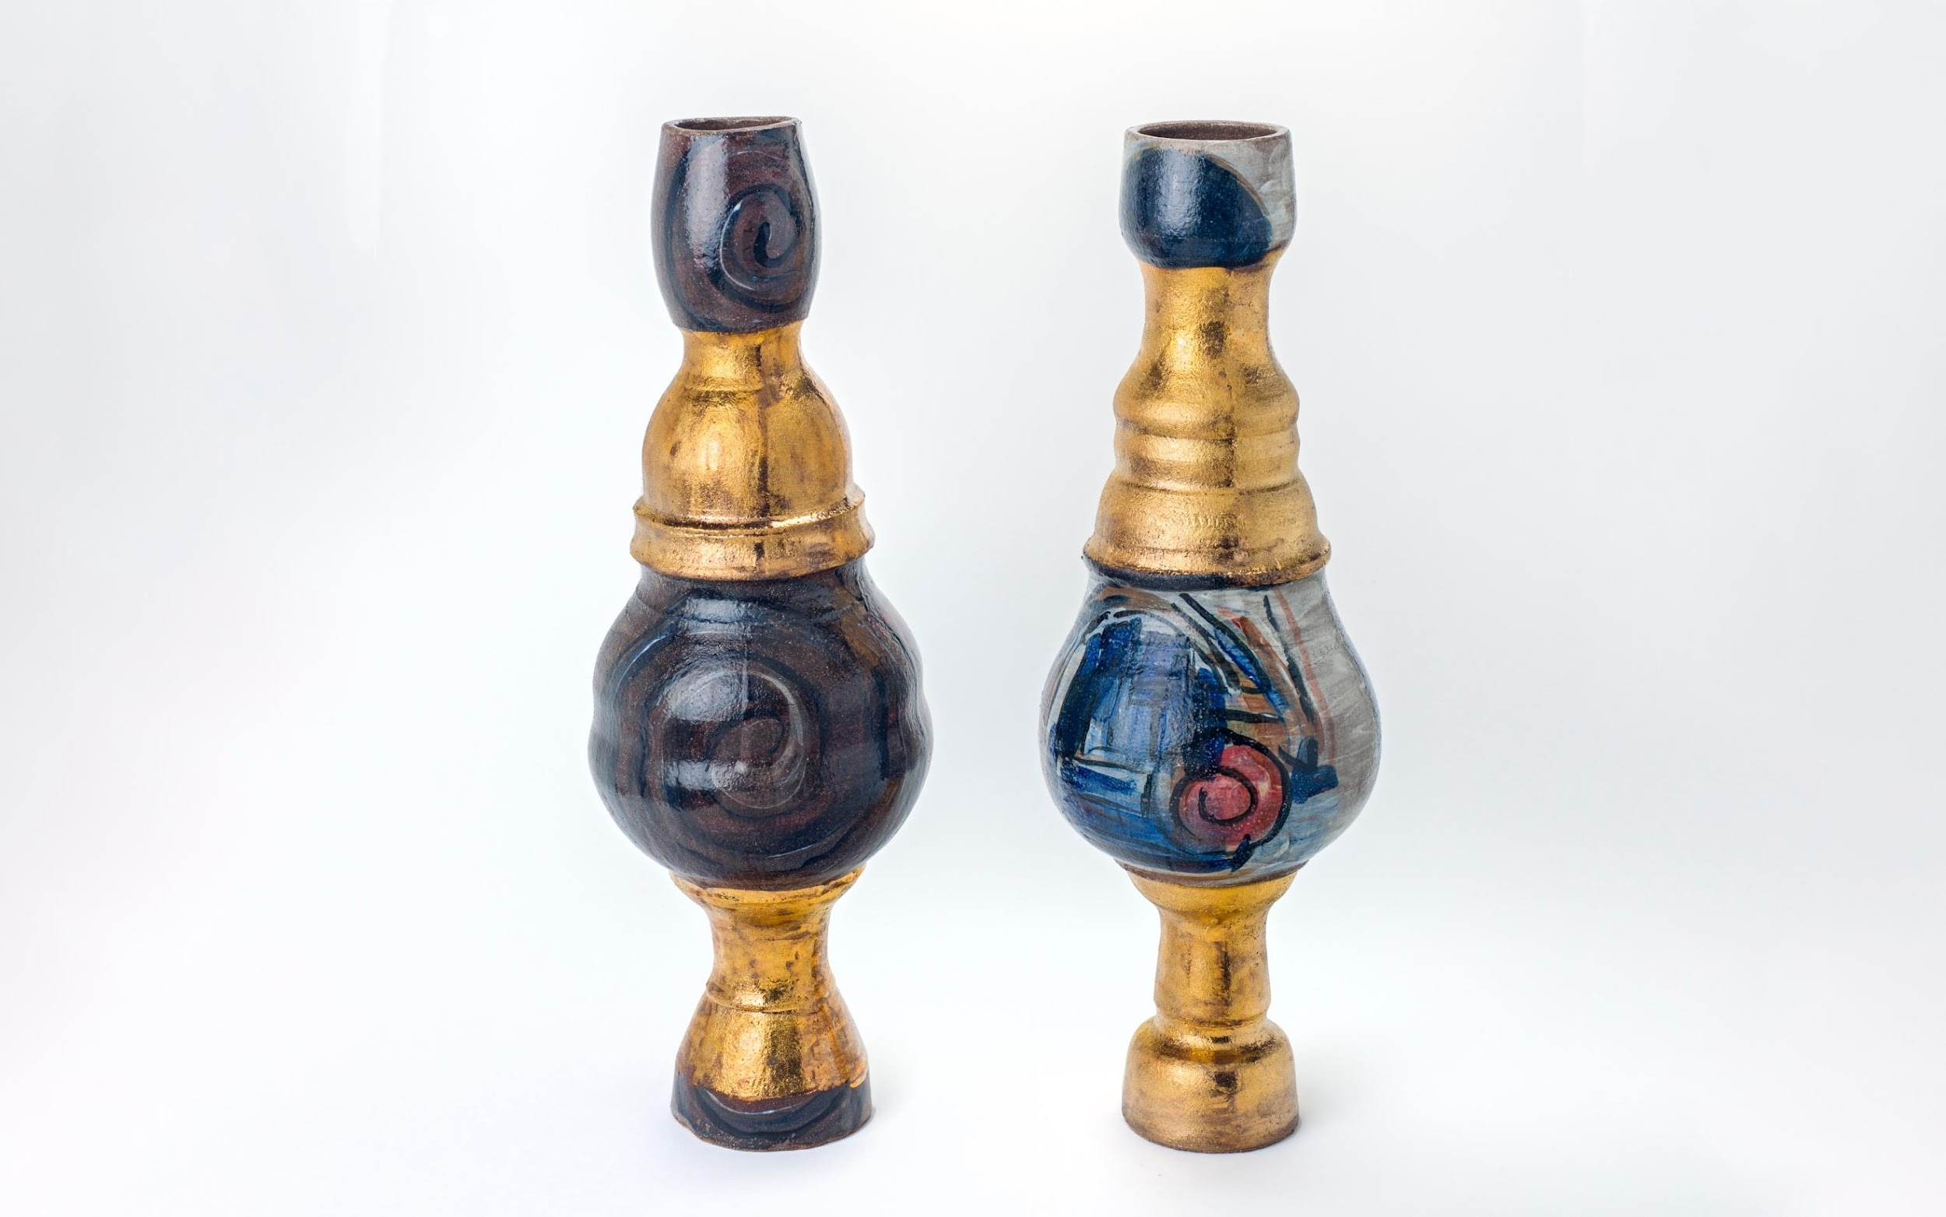
Look
Look closely at this artwork, Candy Lady.
Have you ever seen a portrait like this before?
What can you work out about the person Corbett is introducing us to?

© Shawanda Corbett, Candy Lady (2020)
Think
Think about someone you know or remember well.
Could you create a portrait of them in an unusual way?
Perhaps you could use shapes, colours, or words that remind you of them.

Candy Lady, Shawanda Corbett (1989-present)
Do
Corbett produced this work while listening to music to encourage movement.
Set a timer for 3 minutes. Try drawing your own portrait whilst listening to 3 very different songs, changing the music every 3 minutes.
Does anything change?

2020
Stoneware, thrown, painted and stained, with gold lustre
20cm in diameter and 60-64cm high
C.27-2020

.

More Information
We spoke to Curatorial Research Associate Helen Ritchie about this artwork:
'This pair of large painted vessels forms an abstract portrait of a 'Candy Lady', whom the artist Shawanda Corbett recalls as a friendly older woman who would sell sweets cheaply to local children in the Mississippi community where she grew up. This is part of a series of painted ceramics that capture the individual appearances and personalities of local people remembered by Corbett. These works aim to elevate and give dignity and humanity to individual African Americans often ignored or reduced to stereotypes in the media. In each pair, one piece is designed to suggest the external appearance of the particular character, while the other evokes their internal character and personality.
Corbett is an artist who creates abstract paintings, ceramics, poetry, and performances. Raised between Mississippi and New York, in the United States of America, she is currently studying Fine Art at Ruskin School of Art and Wadham College, University of Oxford.
Born without legs and with only one arm, movement and ideas about what makes a 'complete body’, are key to Corbett's work. In order to create large-scale works using just one hand, she devised a novel way of throwing clay, upside down; and decorates through rhythmic movement. She improvised the painting on Candy Lady, for example, while dancing to 'Part 3: Pursuance' from John Coltrane's acclaimed 1965 jazz album, A Love Supreme.
The Fitzwilliam is the first museum worldwide to acquire Corbett’s work for its core collection. I am especially pleased as this pair is such a brilliant addition to our holdings of contemporary ceramics. It is the only work currently in the collection both made by, and depicting (albeit abstractedly), a black woman. We hope it will set an exciting new precedent.'
If you would like to learn more about the brilliant work of Corbett you can listen to Russell Tovey and Robert Diament on their Talk Art podcast, and read an article by Isabella Smith for Crafts Council.

