This activity has been designed as a starting point for looking, talking and doing together. The **Look** and **Think** activities should take 5 -10 minutes.

The **Do** activities might take longer depending on the task and how creative you are feeling!

**Think**

Thousands of Eye idols like these were excavated from a building now called the Eye Temple.

Why do you think people left these objects together in one place?

Do you have any collections of special things?

**Look**

Max Mallowan coined the name 'Eye idols' in 1937-38 during excavations at Tell Brak in Syria.

Look around at peoples' eyes. How many different shapes can you see?

How could you draw your eyes so others recognise them?

© Isaam Kourbaj

**Don’t Wash Your Hands: neither light agrees to**

**enter the eyes nor air the lungs, Issam Kourbaj**

**Aleppo soap, 2020**

**Various sizes**

**Do**

Make your own eye idol. You could use plasticine, play-dough, or blu-tack. Or make some salt dough! Find a recipe online.

Fancy a challenge? Try sculpting blindfolded, like Isaam Kourbaj did, guided by your memory.

**More information**

These 366 eye idols were created by the artist Issam Kourbaj in 2020 during the national lockdown. They are made of Aleppo soap, a material invented thousands of years ago by the Mesopotamians in the Ancient City of Aleppo in Syria. This popular soap is still made and used today.

The eye idols have been displayed alongside three unique Eye Idols that are a part of the Fitzwilliam collection. These three idols, made of alabaster, date to around 3200 BC.

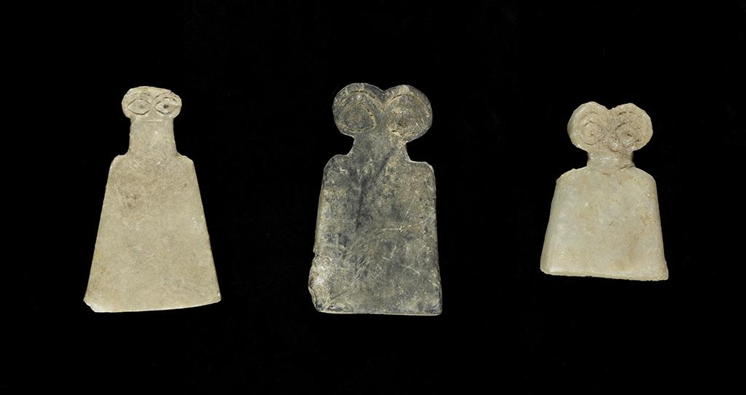

Thousands of Eye Idol figurines (dated ca. 3700–3500 BC) made of different types of stone and more rarely produced in fired clay, were excavated at Tell Brak, Syria, in a building now called the Eye Temple. They are often interpreted as votive objects dedicated to an "eye god" venerated in the temple of Tell Brak. Many are incised with multiple sets of eyes, others with jewellery, and some with representations of "children"— with smaller eyes and a body carved on the body of the larger idol. It is believed that the wide eyes demonstrate attentiveness to the gods in Mesopotamian art.

Upon experiencing the ancient figurines at the Fitzwilliam Museum, Issam Kourbaj found that their simplified ‘contemporary’ form and exaggeratedly large eyes spoke volumes about both absence and presence. The work he created for the Fitzwilliam Museum’s display is a cry to the world, pleading that they do not ‘wash their hands’ of Syria, he has dedicated this work to the Syrians who are still unable to see the light or breathe the air of freedom, yet are working towards a better future.

Issam produced the new sculpted works whilst blindfolded. He was inspired by the size of the older objects that could fit easily in a hand, as well as being unable to visit the museum in person due to the national lockdown. This meant he relied on his memory of the objects, but also memories of his families and friends to create new collections of idols. You can hear more about Issam's process of making in this podcast  [**'In My Mind's Eye**](https://beta.fitz.ms/conversations/podcasts/in-my-minds-eye/in-my-minds-eye-the-museum-explored)' produced earlier in the year for the [**museum**](https://beta.fitz.ms/conversations/podcasts/in-my-minds-eye/carving-soap-while-blindfolded-issam-kourbaj), and find out more about the works [**here**](https://beta.fitz.ms/objects-and-artworks/dont-wash-your-hands-neither-light-agrees-to-enter-the-eyes-nor-air-the-lungs-2020).