This activity has been designed as a starting point for looking, talking and doing together. The Look and Think activities should take 5 -10 minutes.
The Do activities might take longer depending on the task and how creative you are feeling!
Look
Look carefully at this sculpture. The title gives us a clue of what it is supposed to be: a head.
What else does it remind you of?

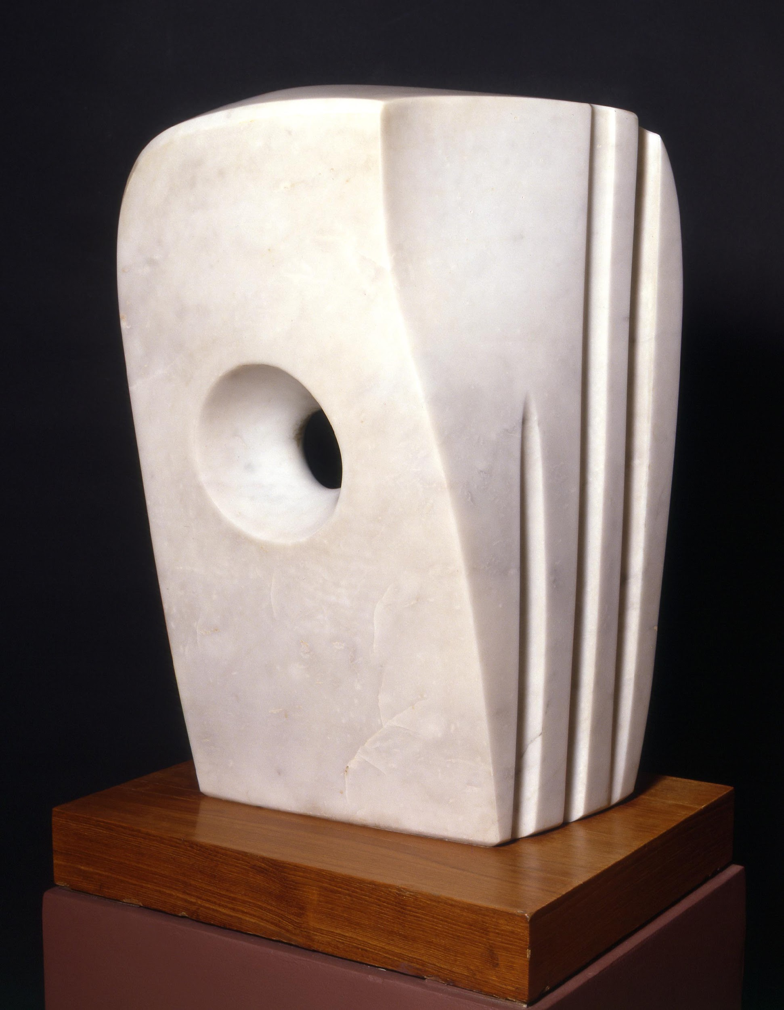
Think
This artwork is known as an abstract form.
In 1946 Barbara Hepworth wrote, ‘I spend whole periods of time drawing when I search for forms and rhythms and curvatures for my own satisfaction.’
Can you abstract the view from your window by following the steps on the next page?

Barbara Hepworth © Bowness.

Minoan Head
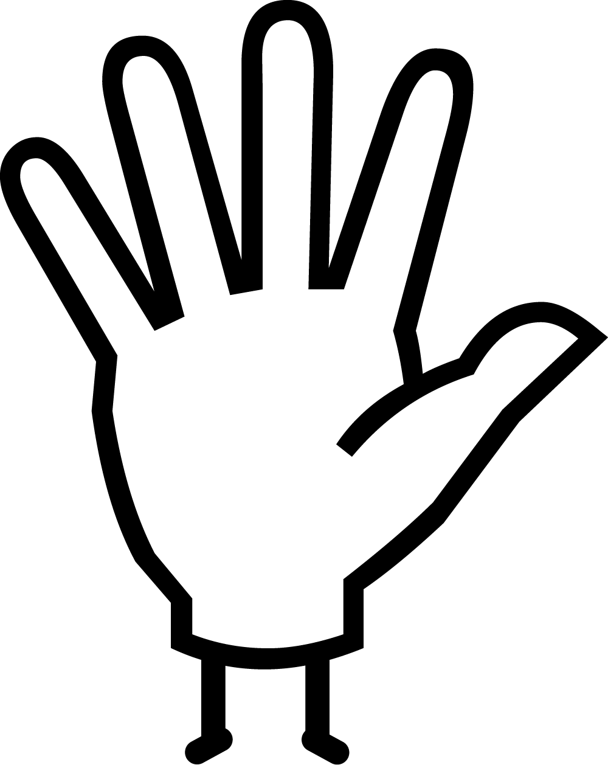Do
Carve your own soap sculpture inspired by the shapes, forms and lines you see around you with the help of this video.
There are some pictures on the next page to help guide you.

Barbara Hepworth (1903 - 1975)
1972
Marble on wooden base
M.11-2000

Hepworth was born in Wakefield, Yorkshire in 1903. In the early 1920s, she studied at Leeds School of Art alongside fellow Yorkshire-born artist Henry Moore. Both artists continued their studies together at the Royal College of Art in London, becoming leading artists in the avant-garde method of direct carving (working directly into a material without making models first).
In 1931, Hepworth met the artist Ben Nicholson, who later became her second husband. At the outbreak of World War II, Hepworth and Nicholson moved to live in St Ives, Cornwall. St Ives had long been a haven for artists, and here they co-founded the Penwith Society of Arts. Hepworth remained in St Ives until her death, which was sadly caused by a fire in her studio.
Minoan Head was made late in her career, but stylistically it has much in common with the sculptures Hepworth produced in the 1930s, when she was moving away from representations of the human body and more towards purely abstract forms.
The Minoan head is inspired by the culture that flourished around the Aegean island of Crete, between roughly 3000 - 1050 BC called the Minoans, after legendary King Minos. Minoan art was discovered at the end of the 19th century by archaeologist Sir Arthur Evans.
Our response to the work depends upon the angle which we view it from. Viewed straight on the sculpture looks like a stylized human head with one wide, all-seeing eye. Seen from the side, the eye socket is more sunken and the curve on the upper right recalls a forehead. As soon as you move around the object your impression changes, making us question what we are looking at.
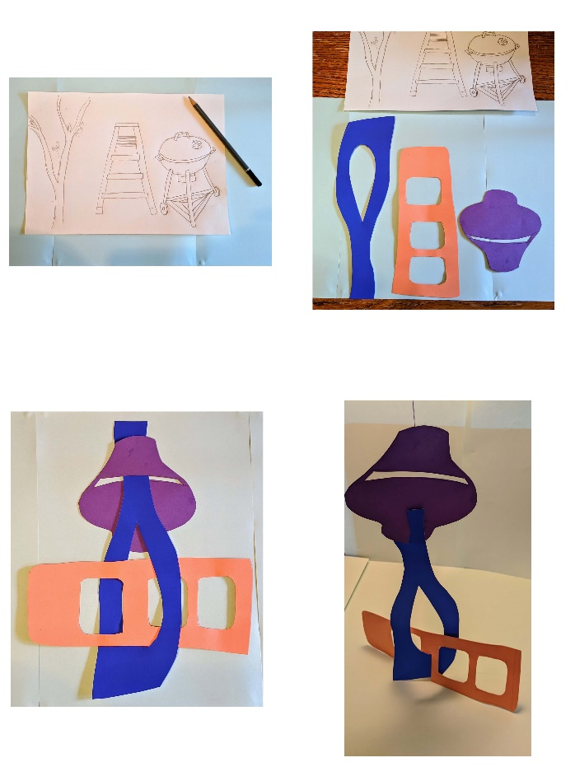
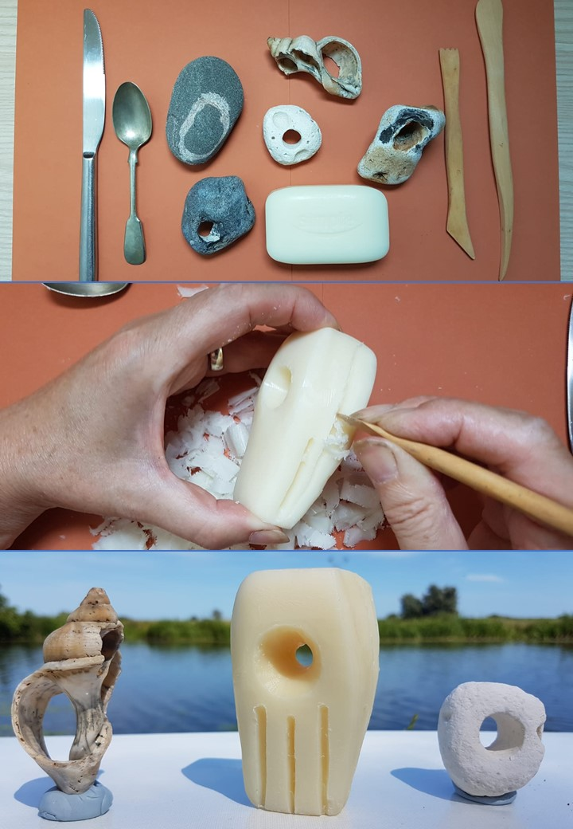
Think Do

