This activity has been designed as a starting point for looking, talking and doing together. The Look and Think activities should take 5 -10 minutes.
The Do activities might take longer depending on the task and how creative you are feeling!
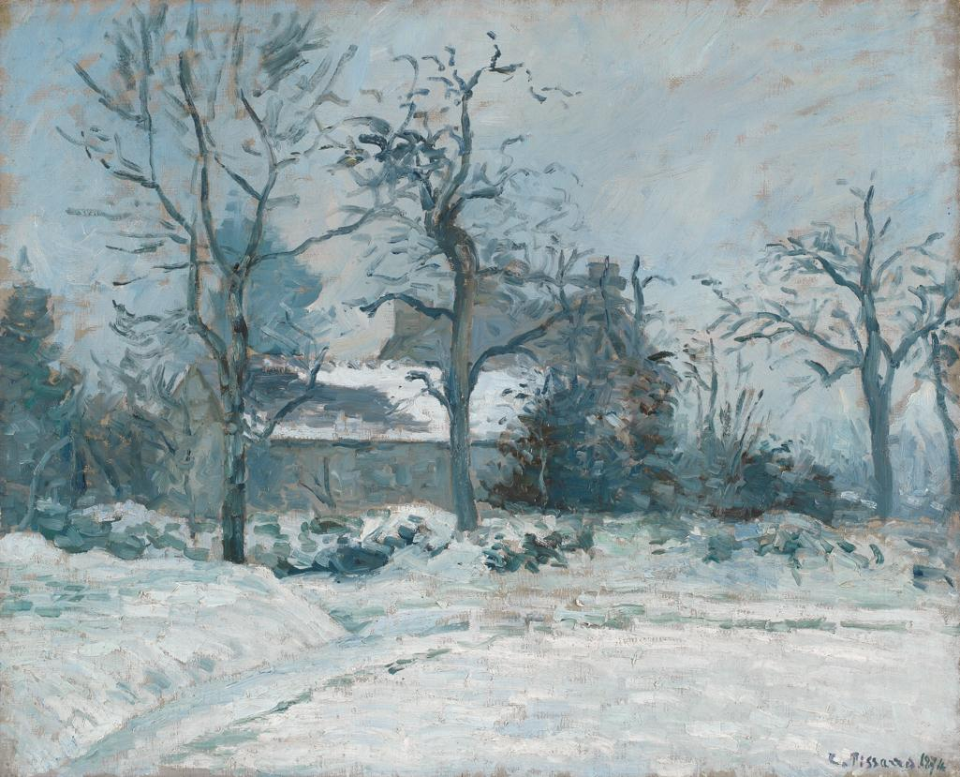
Look
What colours can you see in this scene?
Compare this painting with another snowy landscape by the same artist.
Is snow always white?

Piette’s House at Montfoucault:
Think
Imagine you are an artist painting a snowy scene.
What equipment would you need? What clothes would you wear? What colours would you need?

Snow Effect, 1874
Camille Pissarro (1830 – 1903)
Oil on canvas
60 x 73.5 cm
PD.10-1966

Do
Pissarro painted this picture quickly outside on a cold day.
Find your favourite place outside, and a stick to draw with. Can you trace what you can see on the ground in front of you?
If the ground is hard, collect things to lay on top to make your picture.

Camille Pissarro was born in 1830, in St Thomas in the West Indies but later lived and worked most of his life in Paris. He loved and mainly painted landscapes outside known as ‘en plein air’ which was a very new way of painting. He was influenced by French artists Jean-François Millet (1814-1875) and Jean-Baptiste-Camille Corot (1796- 1875) you can see in our collection who also painted outdoor scenes. In 1873 he helped form a group of fifteen artists, now known as the Impressionists. He was an important part of the group holding them together and encouraging the other members. Art historian John Rewald called Pissarro the "dean of the Impressionist painters", not only because he was the oldest of the group, but also "by virtue of his wisdom and his balanced, kind, and warm-hearted personality".
This painting was made at his friend the artist Ludovic Piette-Montfoucault's (1826-1878) house. Pissarro first visited in the 1860s, but decided to use it as the focus for a series of paintings ten years later. In total he painted eighteen paintings in this area, five of which were in the snow. Shortly before leaving for Montfoucault, Pissarro wrote to his friend about his excitement in travelling there to find, ‘the true countryside’.
Some people hated this new style of ‘impressionist’ painting because they said he made the countryside look muddy and untidy. Luckily, by the time he was in his thirties, most people really liked his painting style.

