This activity has been designed as a starting point for looking, talking and doing together. The **Look** and **Think** activities should take 5 -10 minutes.

The **Do** activities might take longer depending on the task and how creative you are feeling!

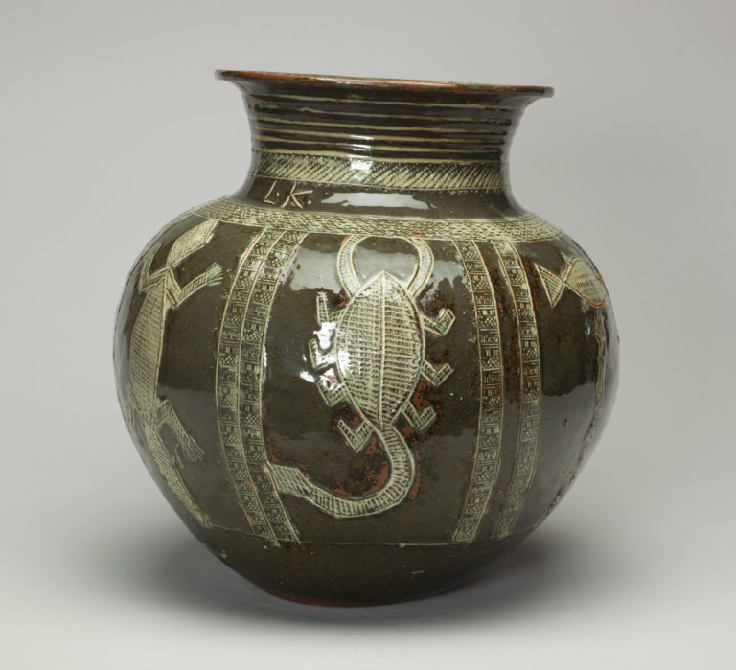

**Think**

This water jar was made in Nigeria, a country on the West coast of Africa, by the artist Ladi Kwali.

She included animals that lived there. What do you think their habitats might be like?

**Look**

This jar is decorated with different animals.

Can you name any of them?

Look at the patterns the artist has drawn into the clay.

We have been unable to trace the rights holder for the estate of

Ladi Kwali, please contact us if you have any information.

**Jar, Ladi Kwali MBE (1925–1984), 1957**

**Hand-coiled stoneware with impressed and incised**

**decoration, green and white slip and a transparent glaze**

**33cm high, 35cm wide, C.364-2016**

**Do**

The shape of this jar was inspired by the way people in Nigeria often stored water at home.

The animals on this jar might be found near a river.

What other habitats can you think of?

Have a go at making your own animal habitat jar following the instructions on the next page.

**More information**

This water jar was made by potter Ladi Kwali, who was born and raised in the Gwari region of Nigeria. As a child, Kwali’s aunt taught her how to make pots in the local, traditional style. Kwali was highly skilled and her pots were very popular. They were collected by the local leader, the Emir of Abuja, where they were seen by British studio potter, Michael Cardew, when he visited Nigeria in 1950. Under the instruction of the colonial British government, Cardew set up a local Pottery Training Centre in Abuja (the Nigerian capital) and invited Kwali to join him. Her work was subsequently shown in exhibitions around the world and Kwali joined Cardew on demonstration and lecture tours to Europe and North America.

Ladi Kwali is celebrated as one of Nigeria’s most successful artists. She was given an honorary doctorate from Ahmadu Bello University, as well as the Nigerian National Merit Award (the highest award for academic achievement) and was made Officer of the Order of the Niger. The Abuja Pottery Training Centre was renamed the Ladi Kwali Pottery Centre in her honour. She also appears on Nigerian currency, on the 20 Naira note!

Michael Cardew taught Kwali to throw on a wheel but mostly she made pots using the local method learnt from her aunt, positioning a pot on a stool or low table and walking around it, coiling the clay and thinning it as she went. Although this piece is called a ‘water jar’, it was not made to be functional but was intended as an exhibition piece for European collectors. It is covered with animals, which Kwali incised and cross-hatched from imagination, without a sketch or plan.

**Do**

You will need: a clean jar, some natural materials, paper, scissors, and paint or colouring pencils.

1. Decide on your habitat. What animal lives there?
2. Gather some natural materials that appear in your animal’s habitat. Perhaps sand, leaves, or pebbles?
3. A picture containing dining table

   Description automatically generatedCreate your animal. We hung our fish from the top of the jar and used plastic and paint so it would survive in water.