This activity has been designed as a starting point for looking, talking and doing together. The Look and Think activities should take 5 -10 minutes.
The Do activities might take longer depending on the task and how creative you are feeling!
Have fun and don't forget to share your creations using #FitzVirtual #LookThinkDo.

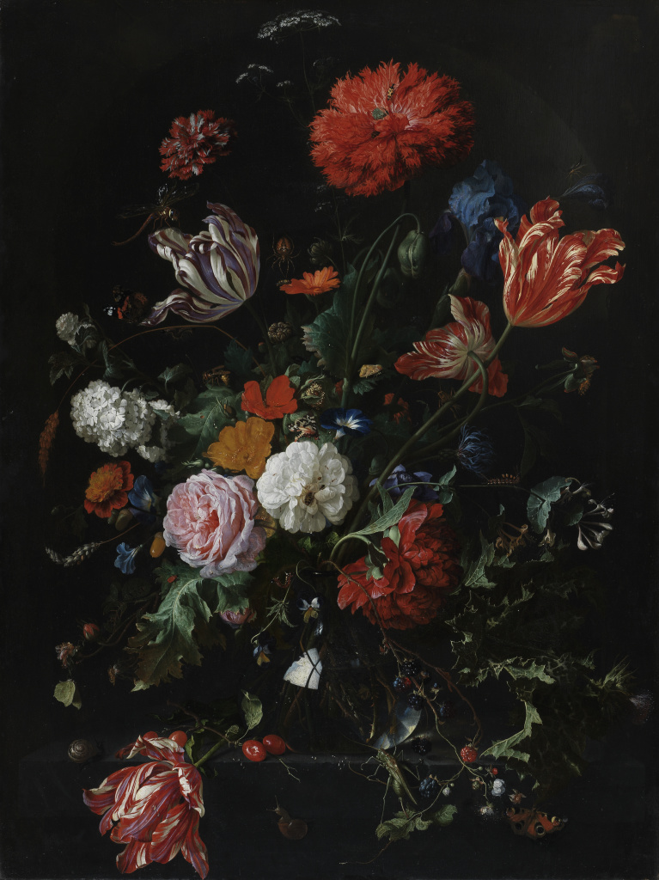
Think
Can you name all the insects?
Now try the same with the flowers!
Answers on the next page.
Look
Set a timer for 3 minutes.
How many insects can you spot?

Now watch our story about this painting Vanessa the Lost Butterfly.

Do
Can you make a still life arrangement of your own?
You can use real fruit and flowers, or other objects that you can find or make.

Flowers in a glass vase
by Jan Davidsz. de Heem
Dutch, 1606-1684
Oil on wooden panel
height 93.2 cm x width 69.6 cm

Jan Davidsz. de Heem (1606-84) was born in Utrecht, just south of Amsterdam in the Netherlands and became one of the most outstanding still-life painters of his time. He painted this in the 1660s when there was a growing interest in the natural world. His minutely painted floral arrangements are crawling with insects, which must have delighted and surprised the collectors for whom these paintings were intended; the more closely you look, the more creatures you see!

You can find out more about de Heem on ArtUK.org

Find out more about how to identify butterflies outside your own window with our friends at the Museum of Zoology.

Answers:
We counted 20 insects:
Peacock butterfly, Red Admiral butterfly, Garden Tiger moth, Brimstone butterfy, Garden snail, Burgundy snail, Comma caterpillar, Scarlet Lily beetle, Milkweed beetle, Hornet (under white and purple tulip), Ladybird, ant, dragonfly, spider, yellow bug (perhaps fruit fly or small horse fly?), crane fly, cricket (x 2- a big one at the bottom and one on the stem of a tulip as if looking out at us)

And 33 individual flowers:
carnation, tulip, columbine, pansies, double poppy, African marigold, marigold, peony, honeysuckle, snowball viburnum, iris, rose, viola, centaura, thistle, convolvulus (morning glory), anemone, cow parsley and Rutpela maculate known as the spotted longhorn on the poppy at the top. There are also branches of blackberries, crab apples, sheaths of wheat and an acorn.

There may well be others, it is very hard to identify them all!

