This activity has been designed as a starting point for looking, talking and doing together. The Look and Think activities should take 5 -10 minutes.
The Do activities might take longer depending on the task and how creative you are feeling!

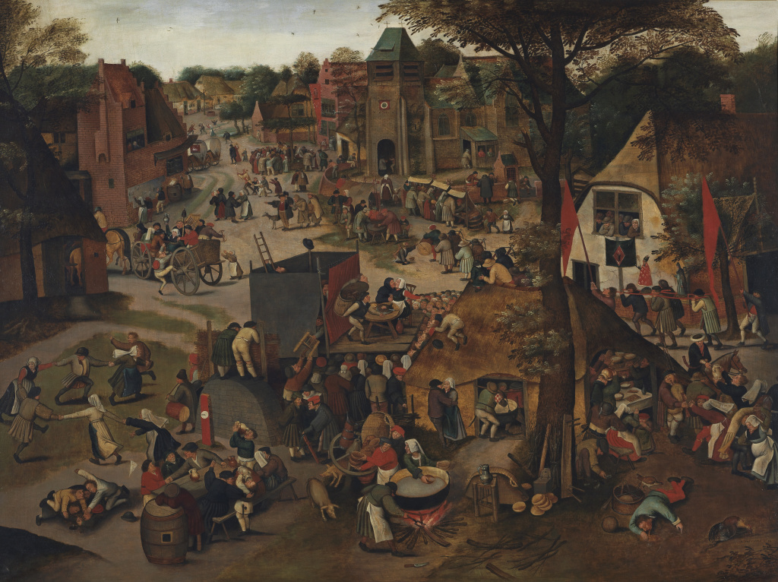
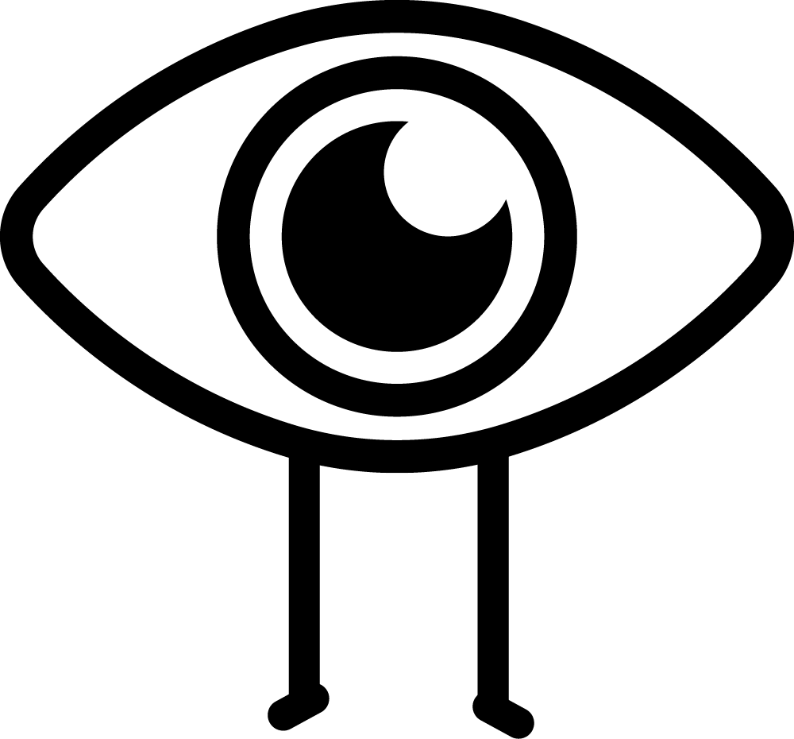Look
Look at all of these people!
They are having a day off on a religious holiday.
Can you make a list of verbs (doing words) to describe what they are doing? e.g. dancing, eating, etc.

Think
Do you ever celebrate things with a big group of people?
Can you think of some nouns (naming words) that describe these people? e.g. villagers, children, etc.

A Village Festival in Honour of St Hubert
and St Anthony, c. 1632
Pieter Brueghel the Younger (1564 - 1638)
Oil on panel
118.1cm x 158.4cm
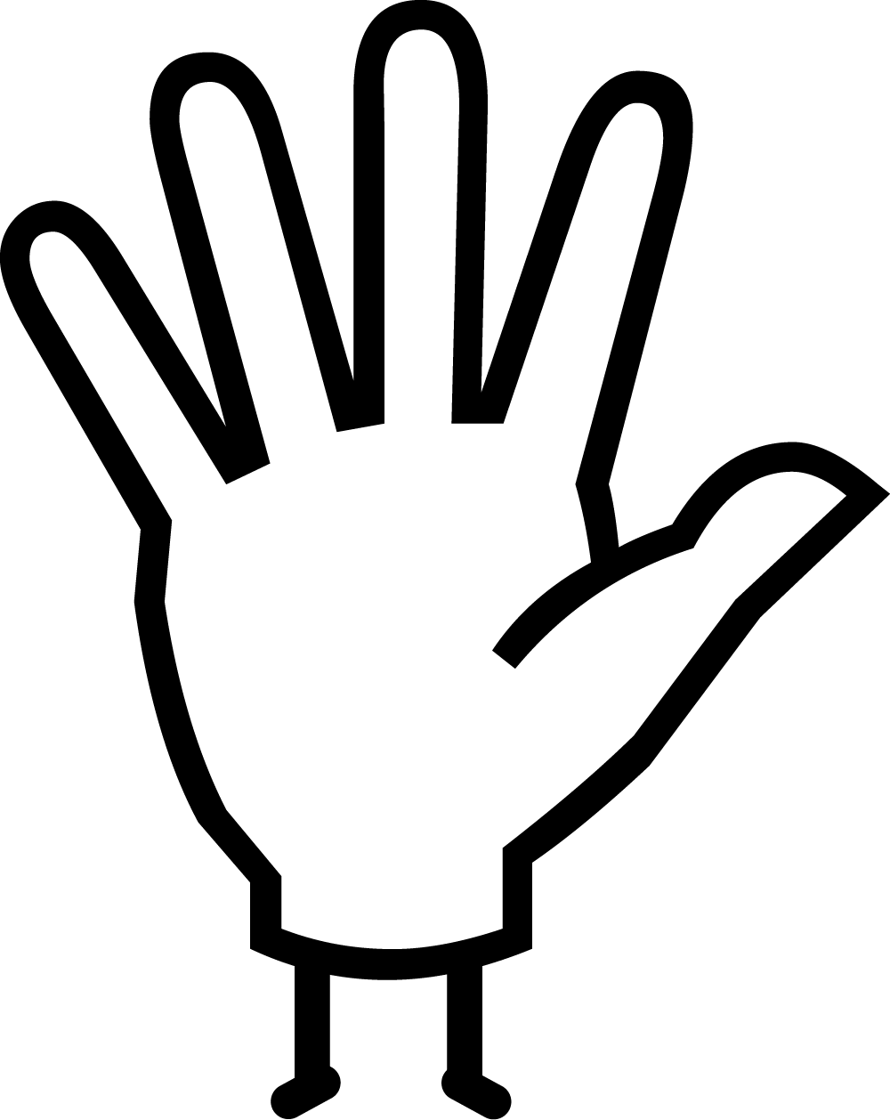Do
Can you imagine the busy hustle and bustle of this festival?
Why don't you have a go at creating your own virtual party by making your own stopmotion animation using a free app, a gif on www.giphy.com, or comic strip?

Brueghel was part of a family of artists who lived in the Southern Netherlands during the 1600s. His artworks, just like this one, often focussed on the everyday life of the lower classes. 'A Village Festival' was so popular that he painted a number of versions, each with slight variations. See if you can spot some of the differences between the Fitz painting and this version at Auckland Art Gallery.
This painting shows a village festival enjoying a festival held in honour of the saints' day for St. Hubert and St. Anthony. To the right of the painting, you can see a procession carrying statues of the saints as they make their way to church. Workers would ordinarily work 6 day weeks with a day off on Sunday. This festival would have given them a much-needed extra day of holiday. Brueghel has contrasted the indulgence and misbehaviour of some of the villagers with moments of happiness and care from others - much like the constitution of our own communities today.
You can see more artwork by Pieter Brueghel the Younger on Art UK.

