This activity has been designed as a starting point for looking, talking and doing together. The Look and Think activities should take 5 -10 minutes.
The Do activities might take longer depending on the task and how creative you are feeling!
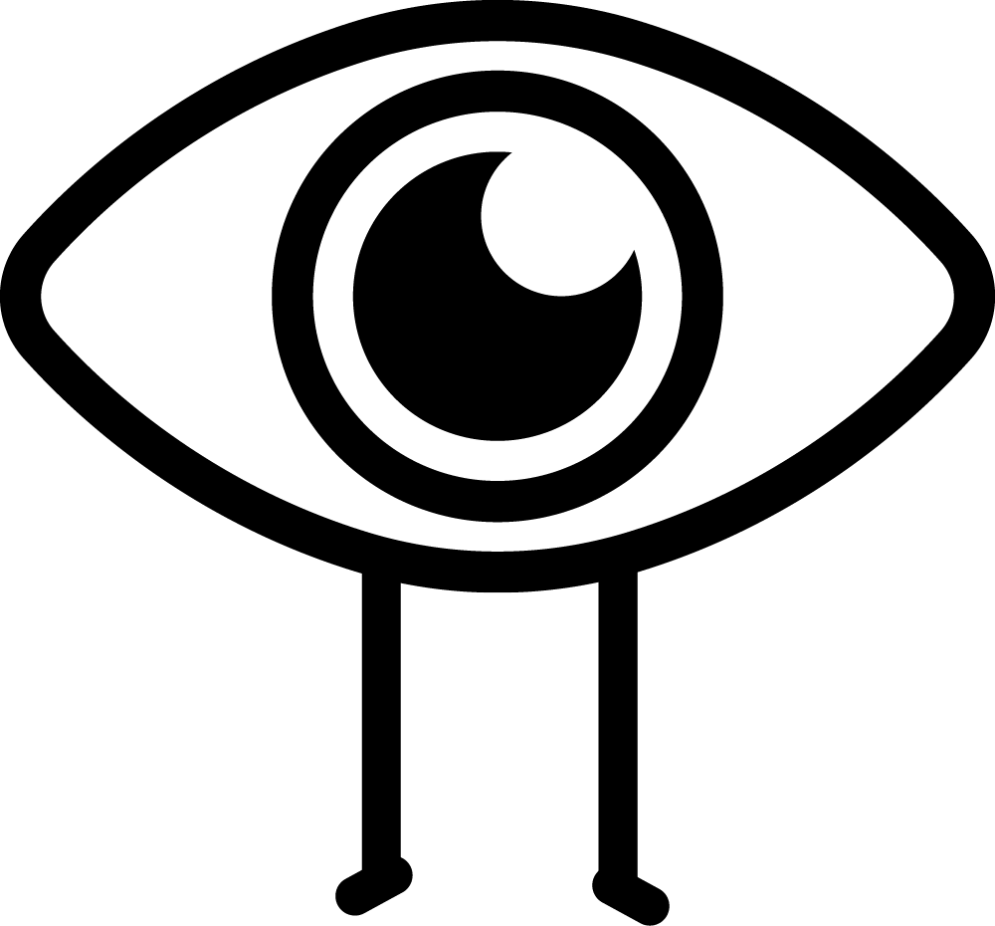Look
Look closely at this bowl made by local potter Elspeth Owen.
Do the colours or marks remind you of anything?

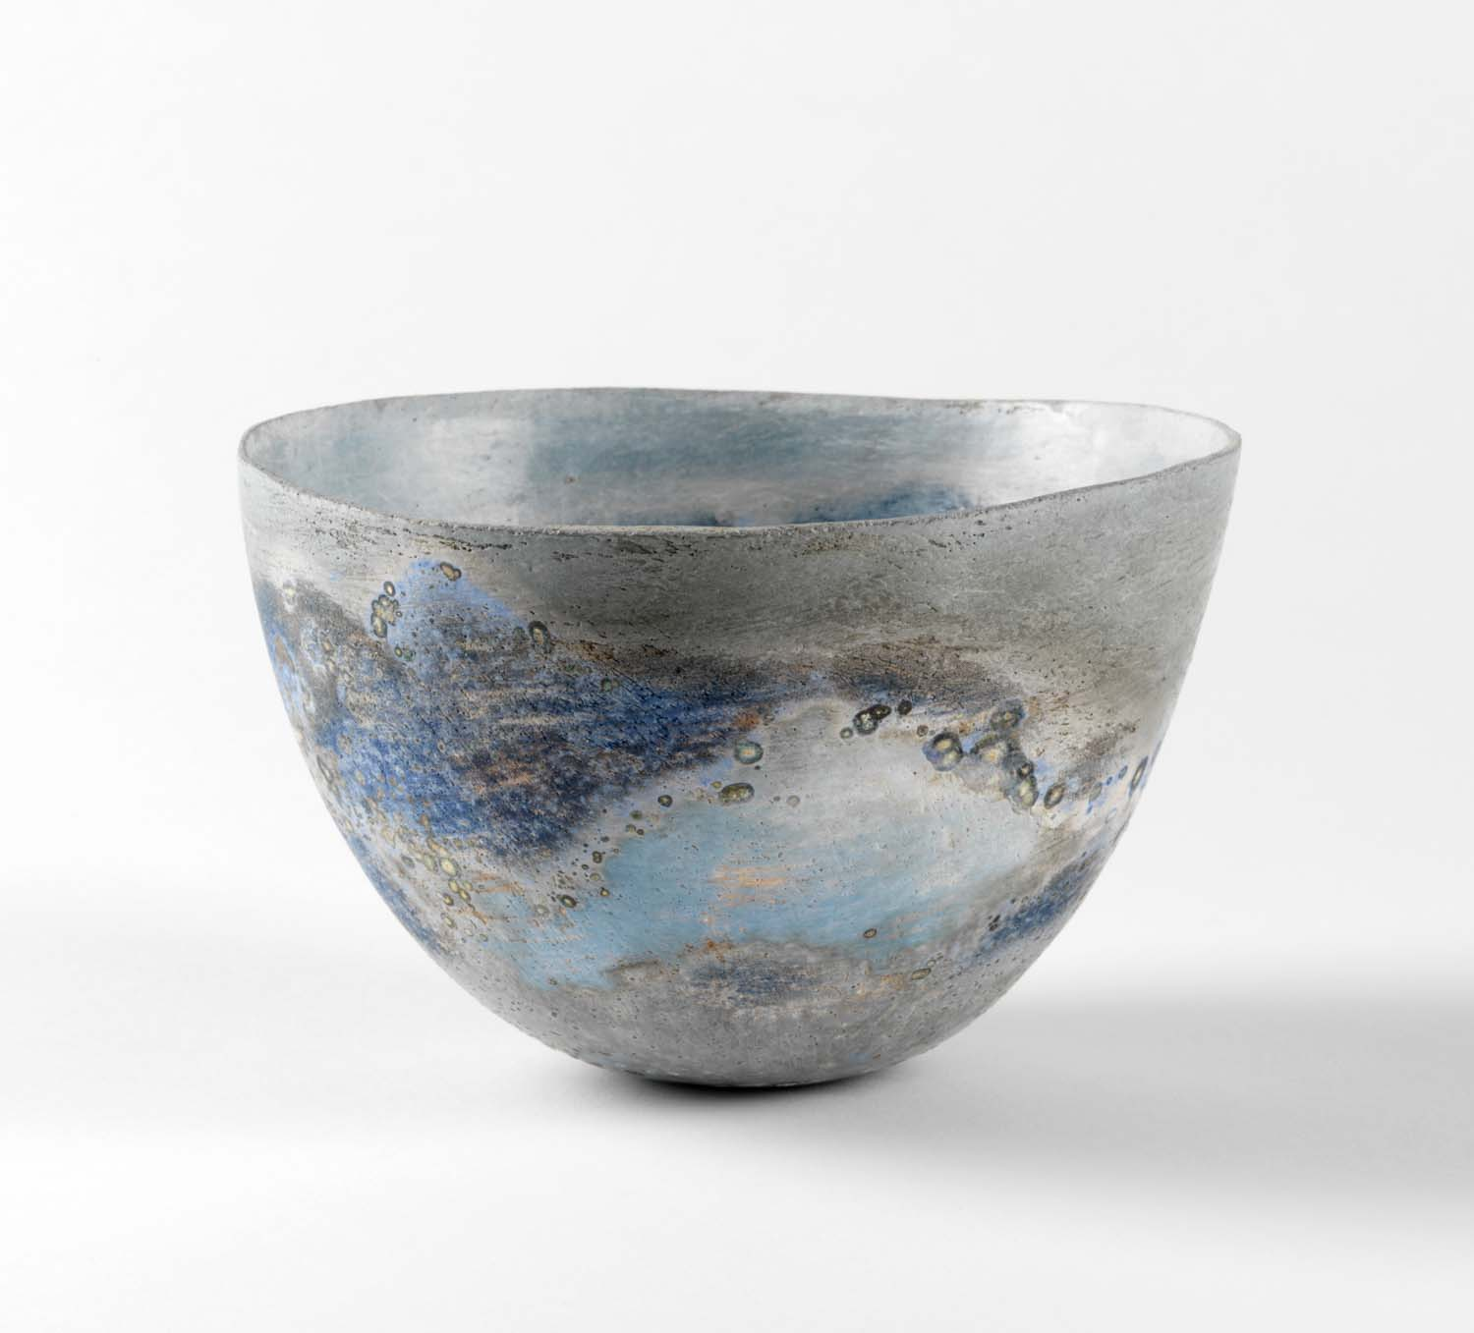
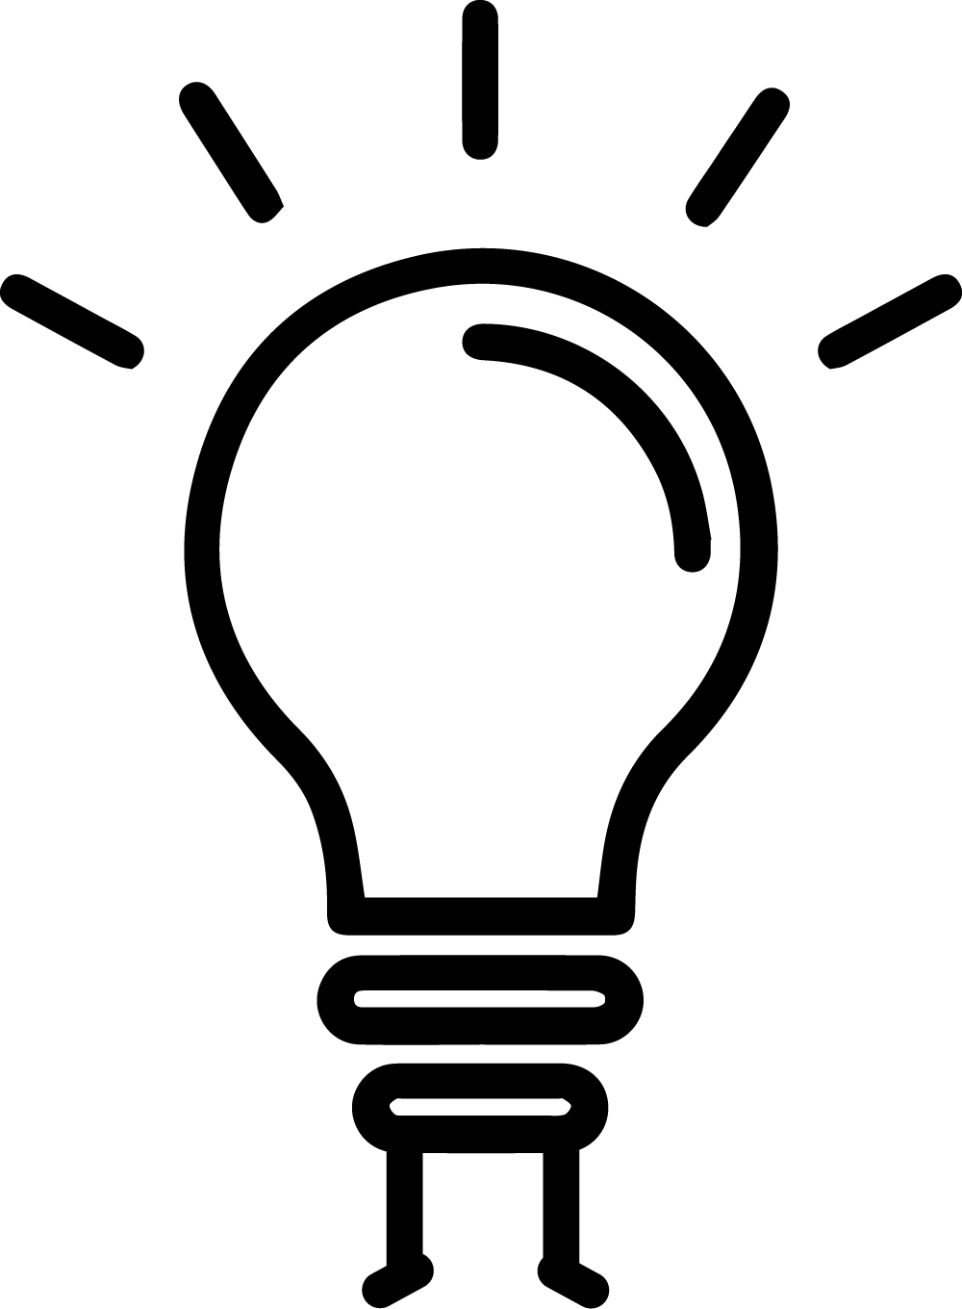Think
The way things feel in our hands is important to Elspeth.
Try the touch drawing challenge on the next page. How does it feel to be guided by touch?

© Elspeth Owen.
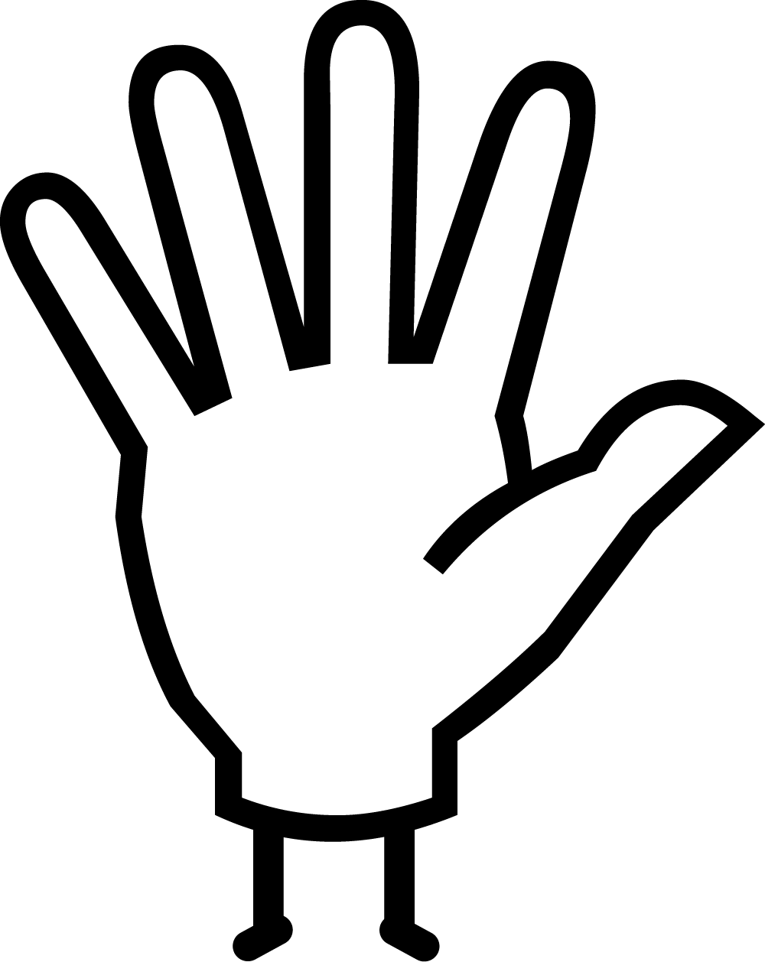Do
Watch our video to find out how to make your own pinch pot.
Elspeth enjoys giving her art way as a gift to people. She calls this ‘gift economy’.
Who will you give your bowl to and why?

Given by Nicholas and Judith Goodison through The Art Fund.
Bowl
Elspeth Owen (b.1938-Present)
Circa 2010-2017
Pinched clay, painted with slips, burnished and polished.
Height 11cm approx. X diameter 17cm approx.
C.47-2017

This bowl was made by potter Elspeth Owen, who lives in Grantchester, a village just outside Cambridge. Elspeth does not throw her pots on a wheel but instead takes a small ball of clay and pinches it into shape, producing delicate bowls and vessels of different shapes and sizes.
She decorates her pieces by painting them with liquid clay (slip) in different colours and then polishes them using a stone. Elspeth has used the same stone for many years, wearing it away on one side.
Touch is very important to Elspeth. She believes that it is only through touch that we can really understand an object – she calls this ‘unavoidable knowledge’. Elspeth makes objects that she wants to be touched and passed between people so she has mixed feelings about seeing her work in a glass display case in the museum, where it is out of reach!

Touch Drawing Challenge
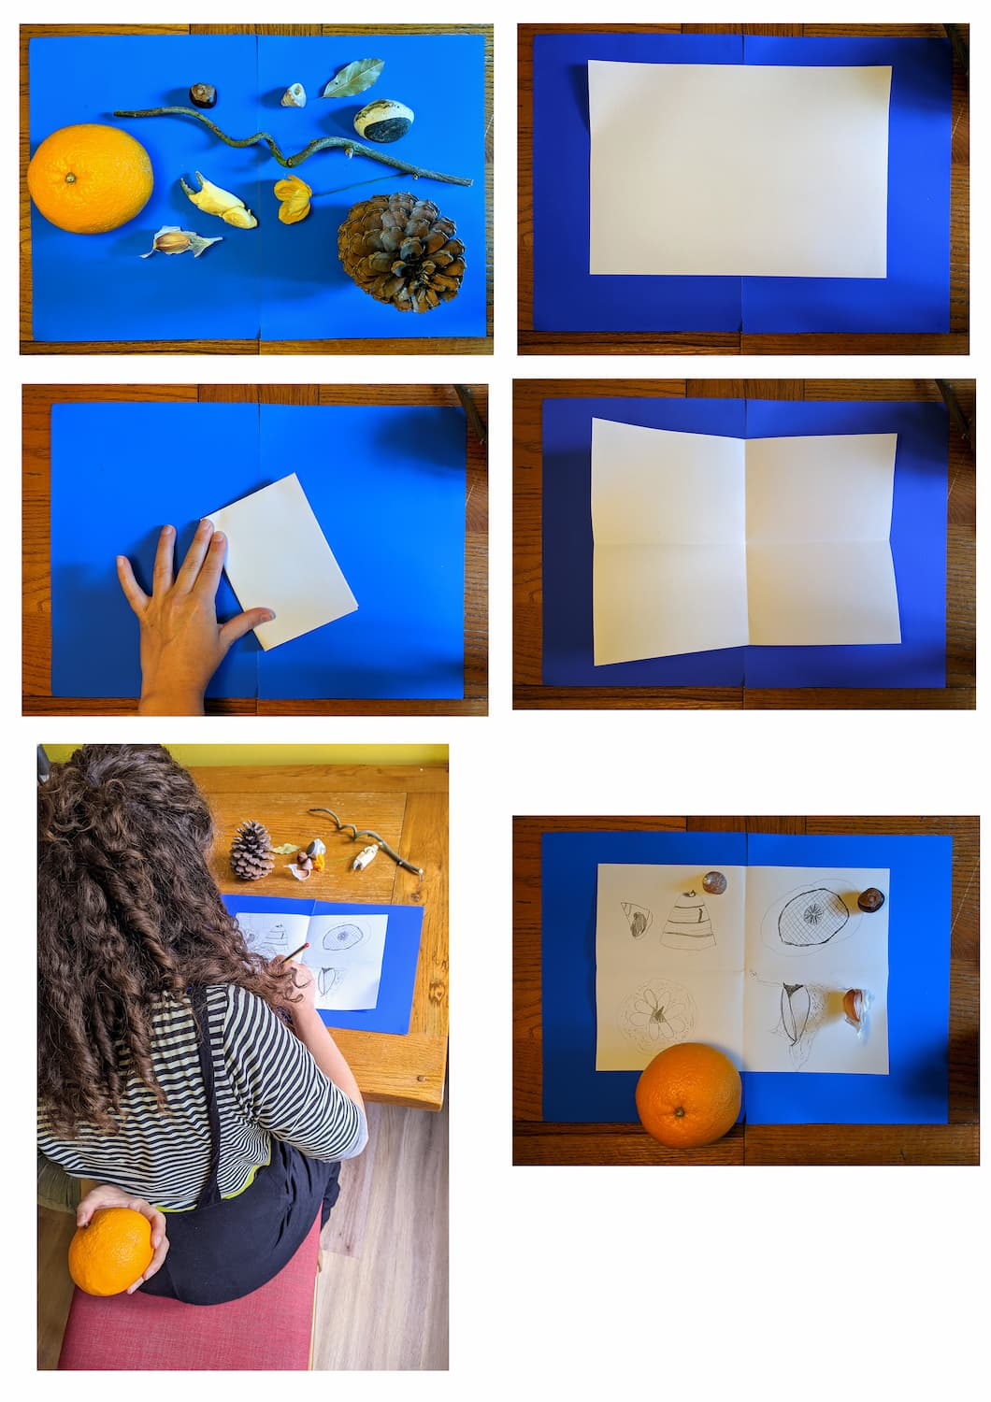This activity is inspired by Elspeth Owen's love for collecting naturally found things like sticks, cobwebs and stones.

Collect as many different naturally made things as you can find in and around your home.
Fold a piece of paper into four to fit more drawings on.
Ask someone to place one of your found objects in your hand held behind your back.
With the other hand try and draw it by how it feels in your hand (without peeking!).
How will you draw sharp, smooth, heavy, squidgy or light things differently?
Compare the objects with your drawings. Do they look different?

Swap with your partner!

