This activity has been designed as a starting point for looking, talking and doing together. The Look and Think activities should take 5 -10 minutes.
The Do activities might take longer depending on the task and how creative you are feeling!
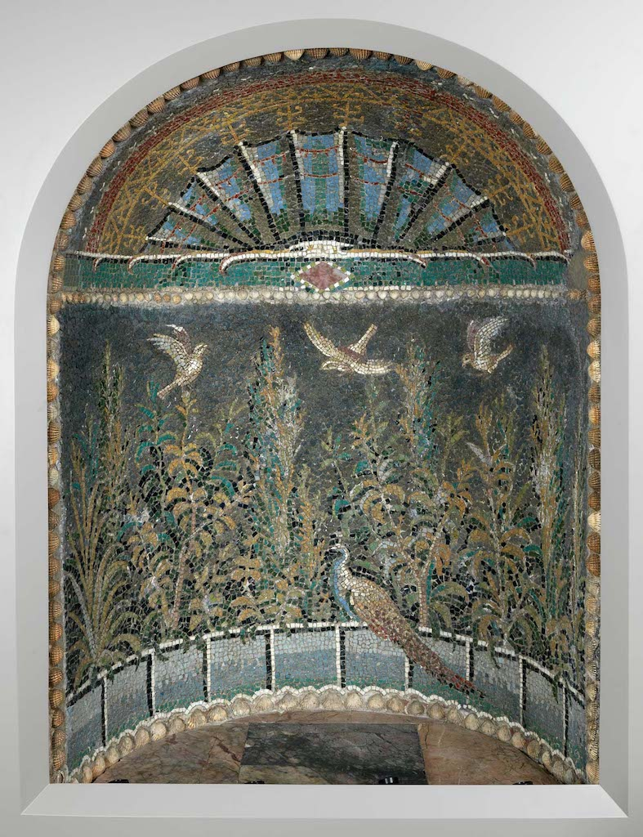
Think
This beautiful mosaic niche once decorated a Roman villa in Baie, near Naples in Italy.
It dates back to between AD 50-70. Can you find this date on the timeline on the next page?
What was happening in Britain at this time?

Look
Set a timer for 1 minute and look really carefully.
When the time is up, look away and make a list of what shapes, colours and details can you remember.
Now have another look and check your answers!

Roman mosaic niche
Do
Roman mosaics were made of thousands of tiny coloured stones and gems. Each one was individually laid by hand into wet plaster.
Watch our video and make your own mosaic.

Baie, Italy
AD 50-70
GR.159.1910

Mosaic floors and decorations were a statement of the wealth and importance of the owner, as many materials such as coloured stones or glass were rare and often expensive. The mosaic consists of a plaster background that has been covered with coloured squares, or tesserae, of glass and other materials including Egyptian blue, marble and other types of stone, bordered with shells. The niche may have held a small statue and the mosaic would have provided an idyllic garden background with three birds coming to land and a colourful peacock already resting at the bottom. The presence of the peacock, an expensive bird and status symbol, indicates that the person who commissioned the mosaic was making a statement about his wealth and position.
