This activity has been designed as a starting point for looking, talking and doing together. The Look and Think activities should take 5 -10 minutes.
The Do activities might take longer depending on the task and how creative you are feeling!

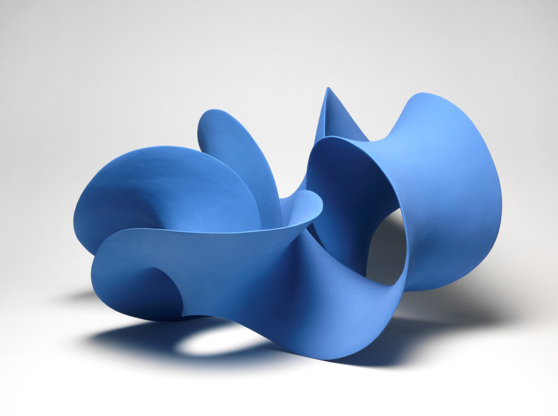
Think
What do you think? Do you like it? Does it remind you of anything?

Look
Look carefully and see if you can work out how this object was made and from what material.

(c) Merete Rasmussen

Blue Twisted Form, Merete Rasmussen
2012, Stoneware
Do
It is amazing to think that this sculpture is one continuous form. If you follow its twists and turns carefully you will see it only has one side. This is known as Mobius Strip.
Cut the edge off a side of paper. Label A and B on the left corners, C and D on the right.
Twist your paper in the middle. Bring the ands around to meet each other and match up corner A with C and B with D.
Sellotape the strip together.
Test your strip using a pencil. Follow it all the way along without taking your pencil off the paper. You will eventually mark all the way along both sides!
31.1 x 57.5 x 52.5 cm
Presented by Nicholas and Judith Goodison
This work is an excellent example of Rasmussen's fluid ceramic forms, with a pleasing asymmetric construction and striking colour.

