This activity has been designed as a starting point for looking, talking and doing together. The Look and Think activities should take 5 -10 minutes.
The Do activities might take longer depending on the task and how creative you are feeling!
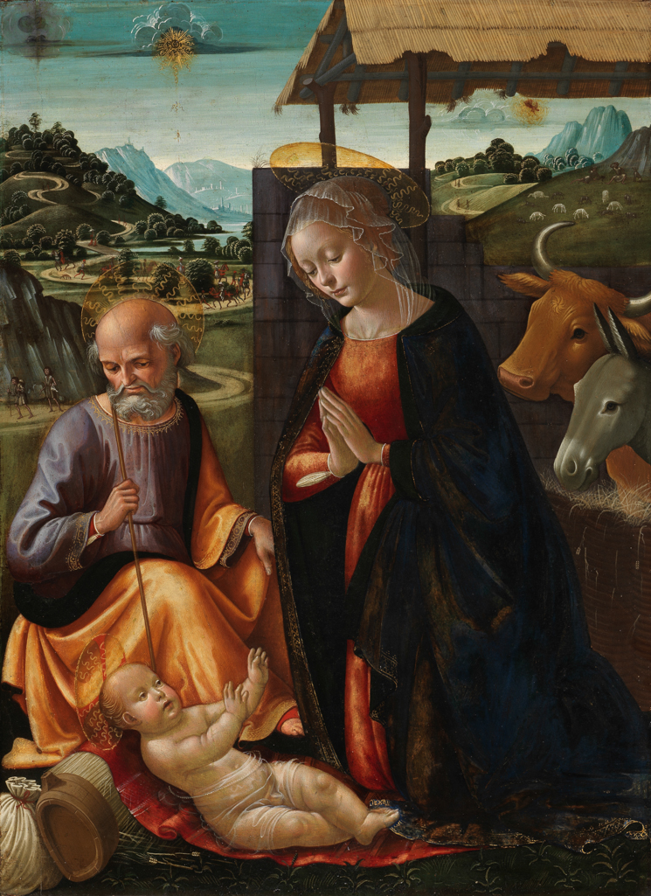
Look
This painting tells the story of the Nativity. You can listen to it here.
Can you spot all the characters from the story in the painting?

Think
Three wise men travel from afar to bring gifts to baby Jesus.
Can you see them travelling on horses in the painting?
What gift would you give to someone special?

The Nativity, Domenico Ghirlandaio, c. 1492
Egg tempera on wooden panel,
Do
Can you see the star shining up in the sky telling everyone the good news?
Follow the step by step instructions in this video and make a star decoration to shine over your holiday celebrations.
85.7cm high x 62.5cm wide
M.54

Domenico Ghirlandaio was born in Florence and was the eldest of six children. He trained as a goldsmith and as an artist in the workshop of Fra Filippo Lippi (1406-1469). After his training, Ghirlandaio ran an art workshop with his brothers David and Benedetto and his son Ridolfo. They specialised in painting on walls in churches, such as Santa Maria Novella and Santa Trinita in Florence. They also made artworks for rich Florentine merchants such as the powerful Medici family. Many apprentices passed through Ghirlandaio's workshop, including Michaelangelo (1475- 1564) who joined the workshop aged twelve. Michelangelo painted the Sistine Chapel ceiling in Rome and went on to become a famous artist and sculptor.
The painting is on a wooden panel. The artist studio would first prepare the surface of the panel by sanding it down and applying layers of gesso (plaster) to create a smooth and non-porous surface. The design would then be transferred from preparatory sketches by a series of pin pricks onto the surface. In a workshop like Ghirlandaio's some artworks would have been worked on by the master himself, while others may have only had the master's finishing touches. For this reason, it is often hard to identify paintings by individuals artists in the 1400s even if they are signed. For many years this painting was thought to have been made by Domenico's brother in law Sebastiano. However, during conservation, cleaning revealed evidence that it was painted by Ghirlandaio himself.
Find out more about wooden panel painting at this time in our Looking at Collections resource.
Want other festive ideas? Have a browse through artworks, videos, stories, and activity ideas on our padlet above.

