This activity has been designed as a starting point for looking, talking and doing together. The Look and Think activities should take 5 -10 minutes.
The Do activities might take longer depending on the task and how creative you are feeling!
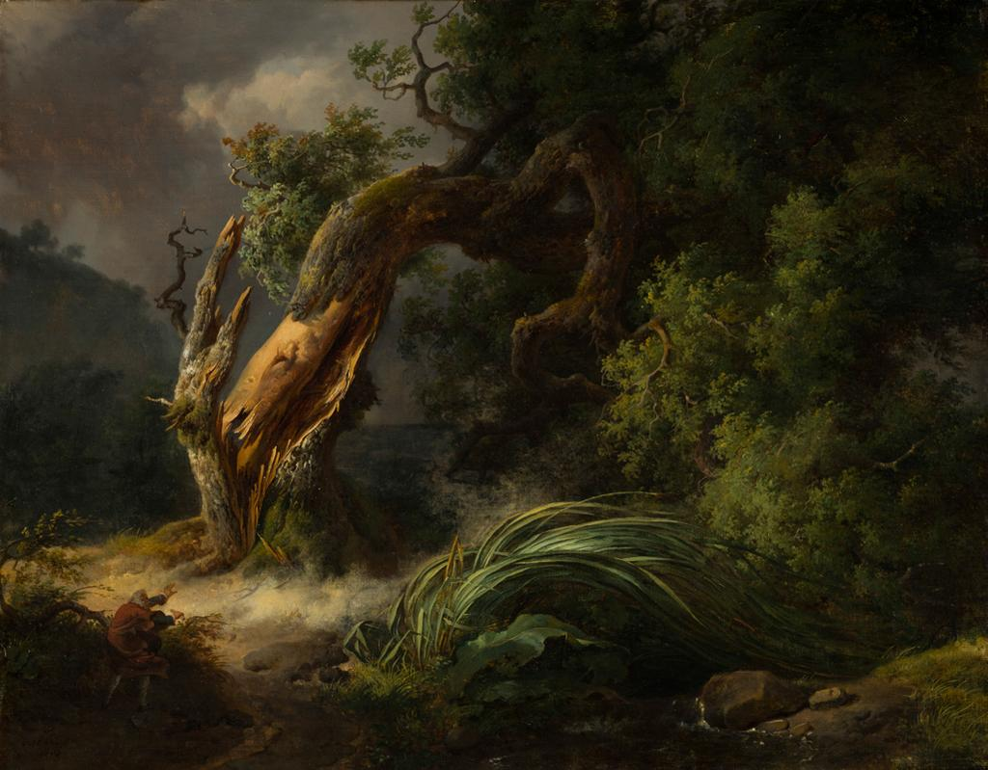
Think
Read the story on the next page. Is it better to be like the reed and give in to the storm or like the oak, standing tall and strong? When might standing strong like the oak be a good idea?

Look
This painting is inspired by a story. In the story, the two characters react differently in a storm.
Can you tell who the characters are by looking at the painting?
The Oak and the Reed,
Achille Etna Michallon (1796-1822)
1816
Oil on canvas, 43.5 x 53.5cm
PD.180-1991
Do
Create your own response to the story by writing a limerick. Follow these tips to get started:
1) The last word of the first two lines need to rhyme, e.g. breeze and sneeze.
2) The last word of the third and fourth lines need to rhyme, e.g. bend and mend.
3) The last word in the final line needs to rhyme with the first and second again, e.g. bees.
Need more tips? We've put an example and some good first lines below.

Michallon was born into a family of sculptors and showed a talent for painting from a young age. The year after this was painted In 1817, Michallon won the first ever Prix de Rome, a prize that awarded an artist money to travel to Italy for 3-5 years. He later set up an artist studio in Paris and went on to teach the famous artist Corot (whose work is in our collection here). Sadly, he died at the young age of 26 of pneumonia, ending the brief career of perhaps the most promising landscape painter of his generation.
The subject matter of the painting is taken from a fable (a short story with a moral message like The Tortoise and the Hare) by the French writer La Fontaine who was working in the seventeenth century. However, the story and moral lesson are much older than Michallon’s painting, or even La Fontaine’s writing. A version appears in Aesop’s Fables (mid-6th century BCE), and related proverbs can be found in Chaucer’s Troilus and Criseyde (1380s), the Ancient Chinese Tao Te Ching (400 BCE) and the Jewish text, the Talmud (4th century CE).
The lesson of the story is one of humility and flexibility in the face of change. Some people, noting the year of the painting (1816), suggest that this fable was a commentary on the fall of the French Emperor Napoleon Bonaparte following his defeat at the Battle of Waterloo in 1815. Having refused to accept the terms of a peace deal with allied European countries, Napoleon surrendered and was exiled to the island of St Helena in the South Atlantic ocean.
This painting is part of a wider project on the theme of nature called Inspire Nature.

The story of the Oak and the Reed
A storm is approaching, and the mighty oak looks down and offers protection to the smaller delicate reed blowing in the wind.
The reed replies that it knows what is needed to survive the storm, and the mighty oak responds with a laugh knowing the force that he feels could not be taken by something smaller.
When the strong winds of the storm arrive, the huge tree tries to face them with brute strength and breaks. But the reed tries a different tactic and survives by bending and yielding to the force of the storm.

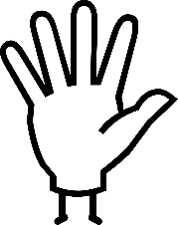Do: write a limerick inspired by the Oak and the Reed

Here is our example:  One day there came a violent breeze  It blew harder than a giant’s sneeze  The reed chose to bend  The oak will never mend  But will still help the birds and bees | Here are some first lines to get you started:  'There once grew a reed and a tree,'  'When you find yourself facing a gale,'  'There once were two plants in a squall'  'What should you do on a windy day?'  'An oak and a reed were having a chat'

