This activity has been designed as a starting point for looking, talking and doing together. The Look and Think activities should take 5 -10 minutes.
The Do activities might take longer depending on the task and how creative you are feeling!
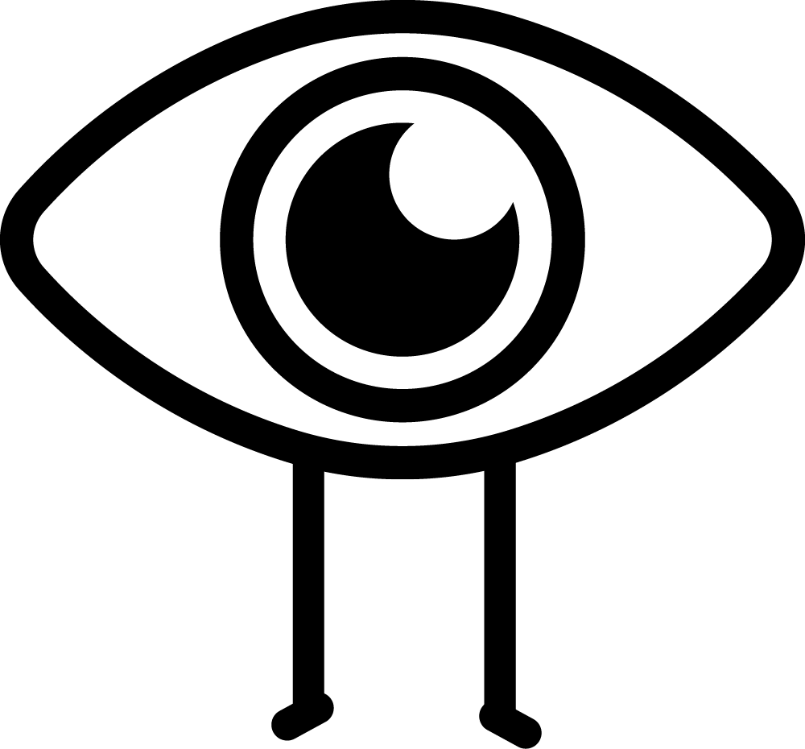Look
Many people have wondered how this was used 2,000 years ago.
Take a closer look, what would you use each bit for?
What would you name each one?

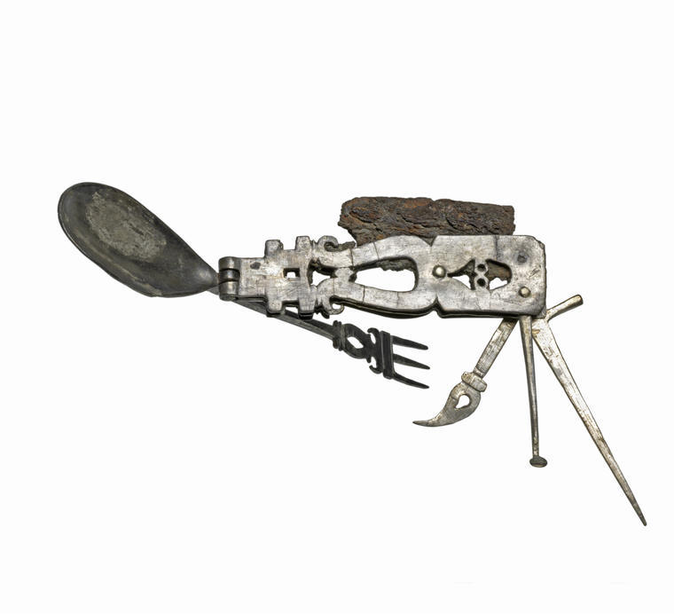
Roman "Swiss Army Knife”
Think
Design a Roman Menu to eat with this tool. Need help with inspiration research?
Have a look at these recipes from the Classical Cookbook by The British Museum.
Make sure it has things to cut, scoop, pick and crack open.

Middle Roman 201 CE - 300 CE
Silver and Iron
8.8cm x 15.5 cm
GR.1.1991

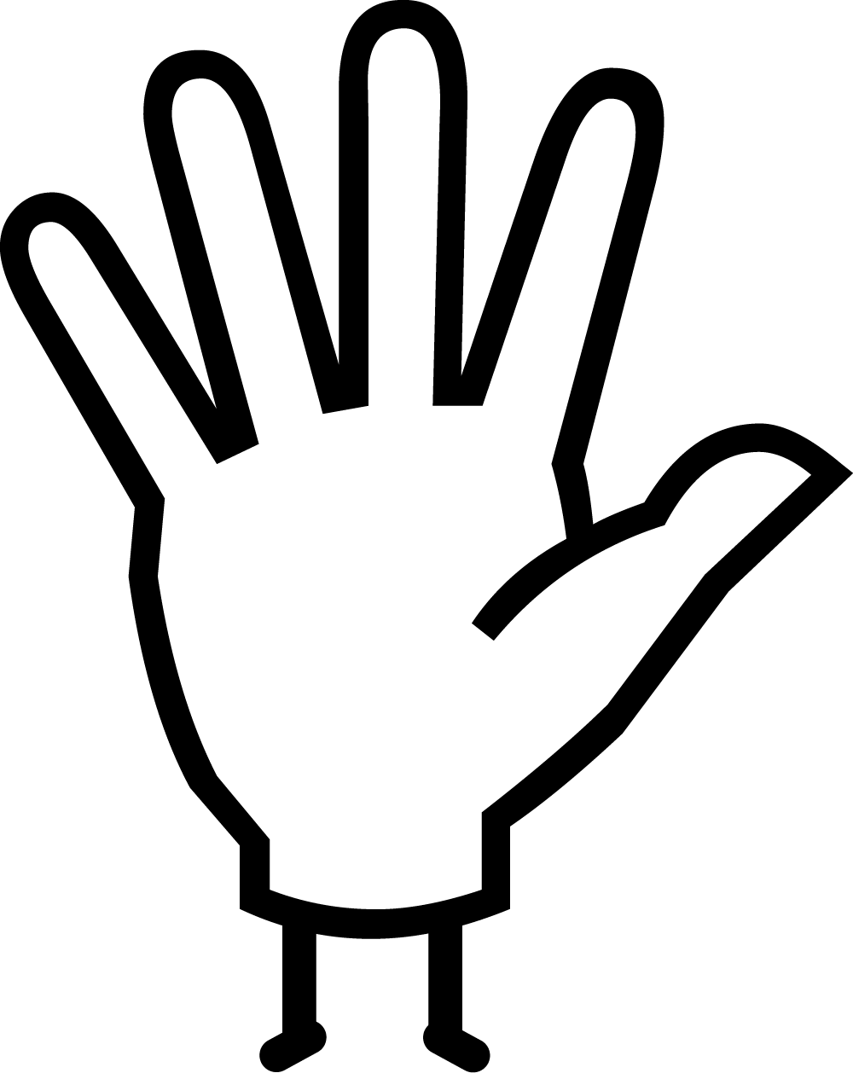Do
Invent and design your own handy tool, what would it help you do?
There a picture of one we made on the next page – use it for inspiration. We used pencils and card, but you could cut tools out from a magazine or you could sculpt them!

This folding eating gadget has a three-pronged fork, a spoon, a spatula, a pick, a spike and an iron knife that has eroded away. There is a hinge to allow each item to be folded out when it was needed, or folded away for ease of transporting it. The spike might have helped in extracting the meat from snails, and the spatula in scraping sauce out of narrow-necked bottles. Some have even suggested the pick with the tiny spoon on the end could have been used to remove earwax.
While many less elaborate bronze folding knives have been discovered from antiquity, this one's complex design and the fact it is made from silver suggests it is a luxury item. Perhaps a useful gadget for a wealthy traveller or soldier to show off, but not really intended for heavy use, as silver is a soft and pliable metal.

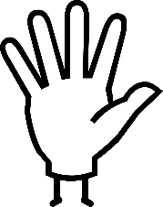Do: Make your own multi-tool
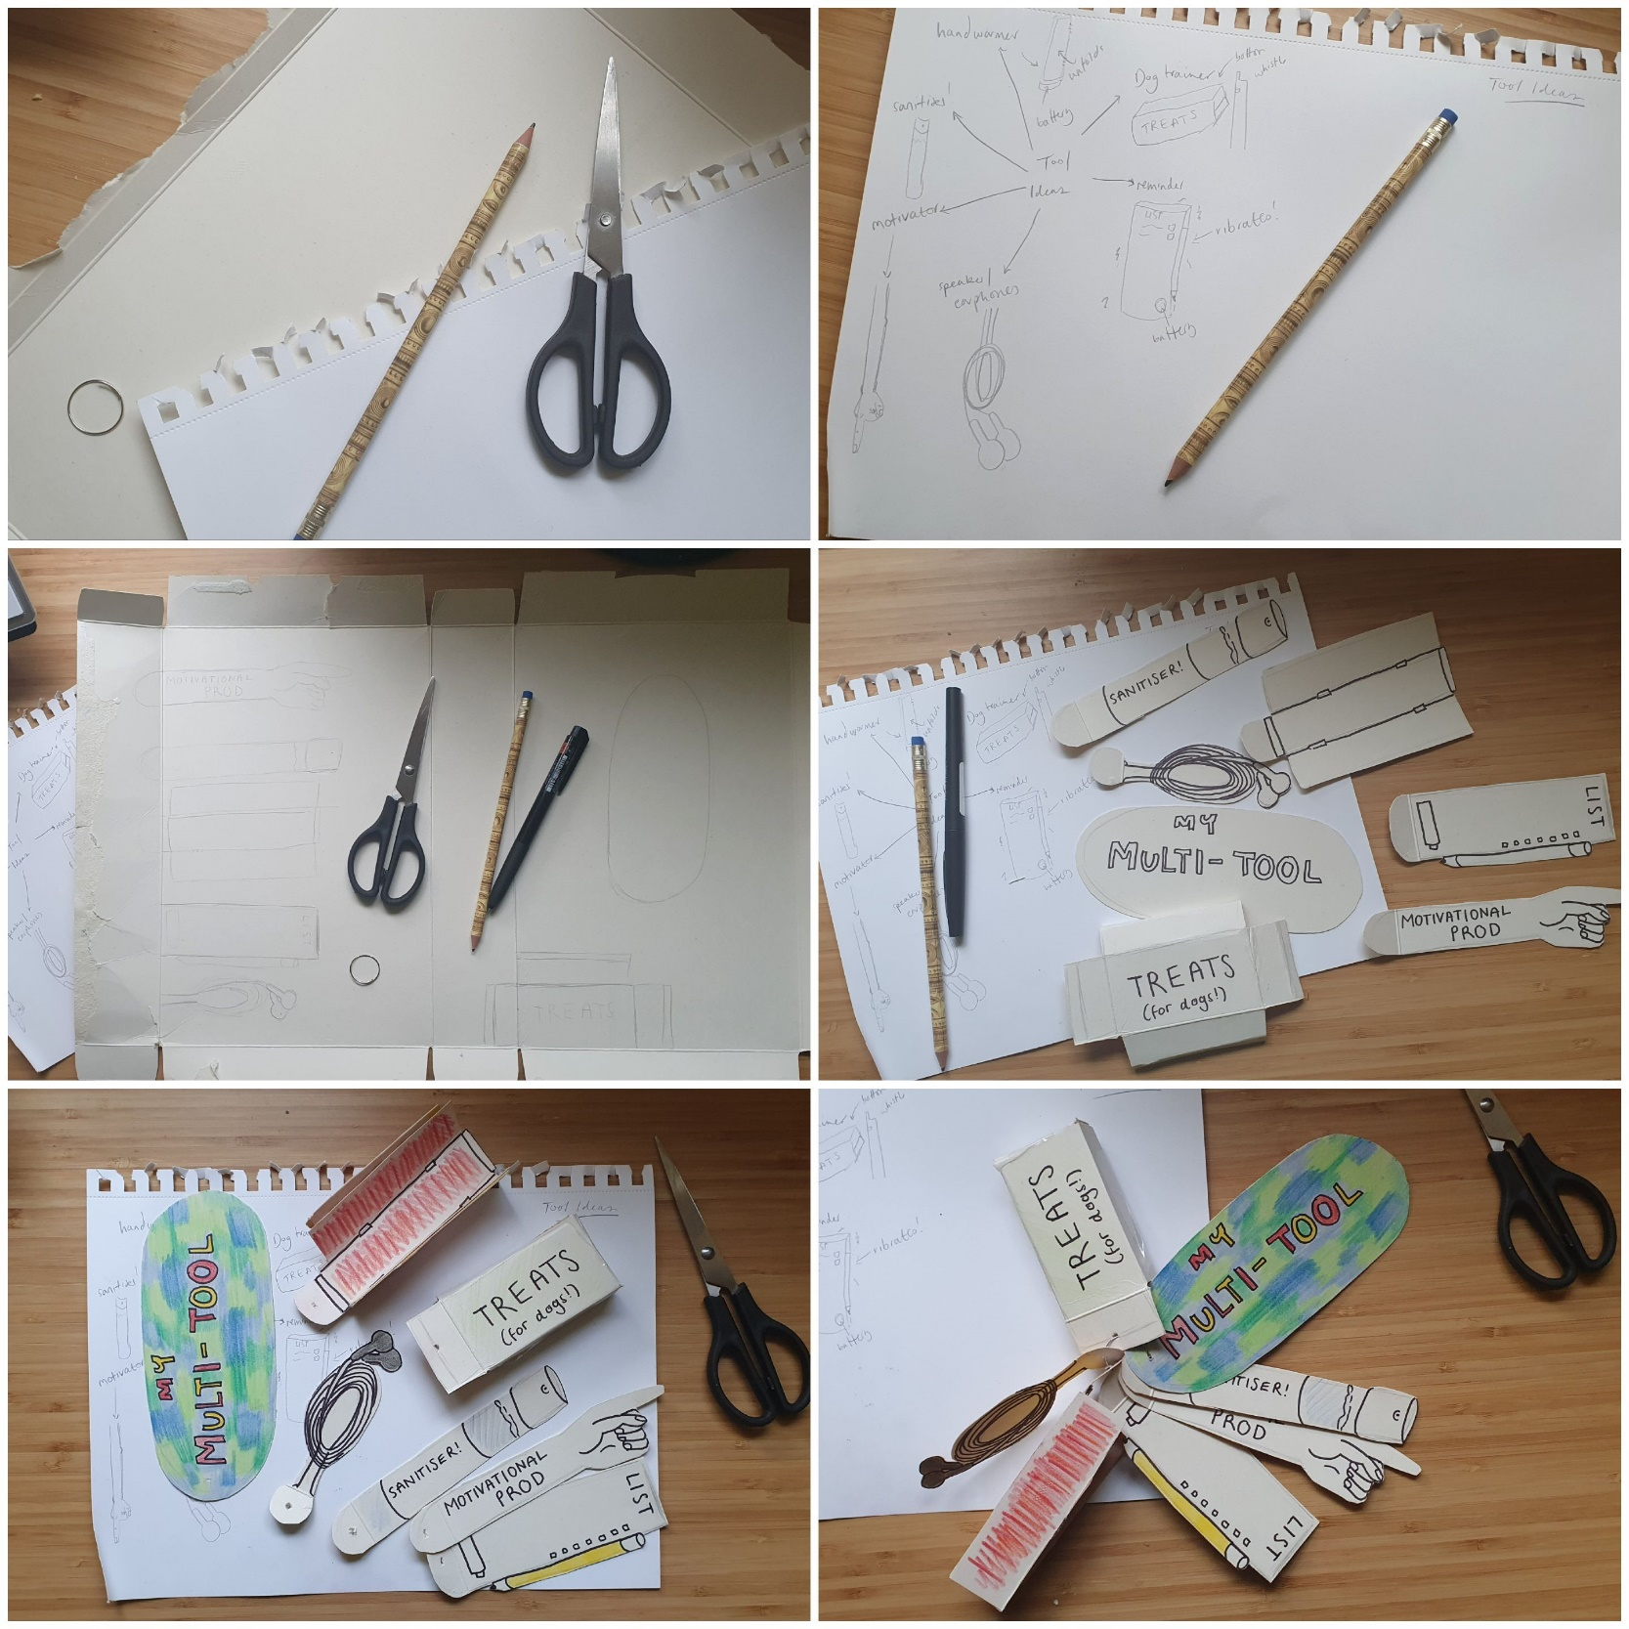
Plan what tools you’d include in your own “Swiss Army Knife” before you design your own!

