This activity has been designed as a starting point for looking, talking and doing together. The Look and Think activities should take 5 -10 minutes.
The Do activities might take longer depending on the task and how creative you are feeling!
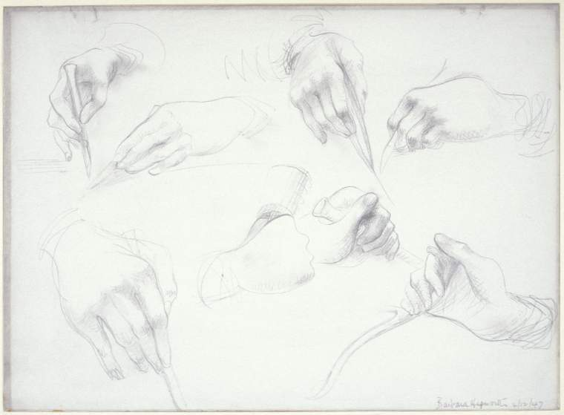
Look
Look at the hands Hepworth has drawn. How many can you count?
Can you copy the positions with your hands?
How does each one feel?
Why do you think she has she chosen to study surgeons' hands rather than a policeman or teacher?
Study of Surgeons’ Hands, Barbara Hepworth
1947
Think
Hands are sometimes one of the hardest things to draw, but you can start by studying your own!
Look closely at your hand. Focus on all the lines, marks and wrinkles.
What is the weirdest, smallest, heaviest or favourite thing you have held?
Can you remember how it felt?

Describe to someone else what you're holding. Can they guess what it is? you include and why?
Graphite on gesso
27.5cm x 37.6 cm
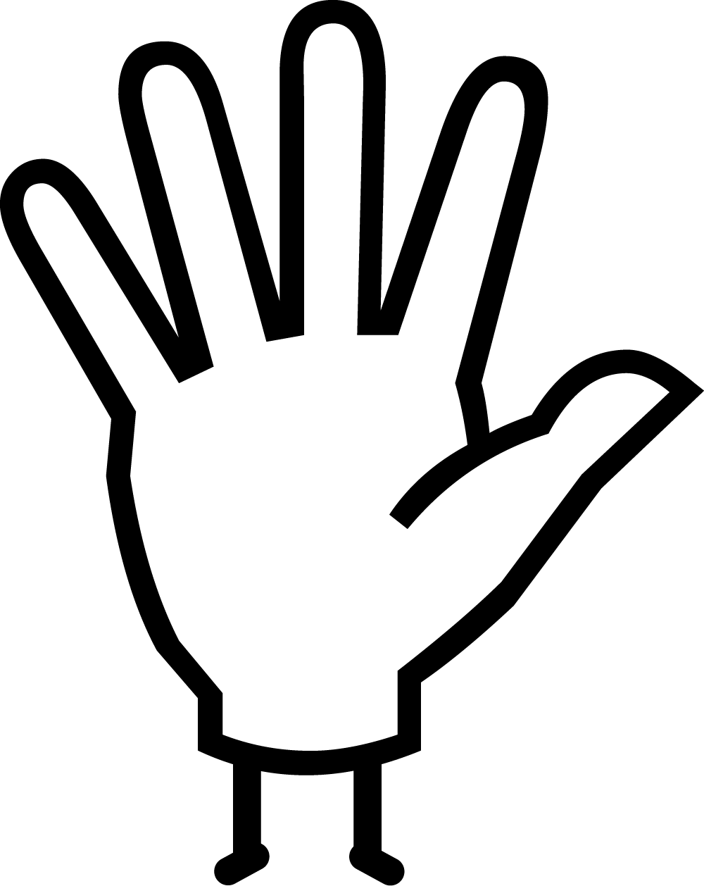Do
Have you tried drawing with both hands at once, or with your other hand?
For something a little different try our 2 min hand meditation on the next page.
You could also try these Touch activities with AccessArt.
Barbara Hepworth was one of the most important sculptors of the 20th century but she is less well-known for her drawings. Between 1947 and 1949, Hepworth sat in operating theatres in Exeter and London, drawing the surgeons and their teams as they carried out a range of different surgical procedures. This idea came after one of her daughters, Sarah, became ill with the bone condition osteomyelitis, in 1944. Hepworth and her husband Ben Nicholson became friends with her surgeon Norman Capener at the Royal Orthopaedic Hospital in Exeter.
When Capener first suggested the idea, Hepworth’s first reaction was “one of horror”. She said “it seemed to me a grim idea”. However, she later said in contrast to this initial reaction what she found in the operating theatre was an atmosphere of “concentration and rhythm”. She said: “From the very first moment I was entirely enthralled by the classical beauty of what I saw there: classic in the sense that architecture and function were perfectly blended and purity and grace of exhibition were in complete harmony.” She found, “a close affinity between the work and approach both of physicians and surgeons, and painters and sculptors”.
Do: Breathe with your hands
Breath with your hands!
- Spread the fingers of one hand out into a star with your palm up.
- With the other hand, point to the base of your thumb.
- Breath in as you slide up your thumb. Breath out as you slide down the other side.
- Breath in as you slide up one side of your first finger. Breath out as you slide down the other side.
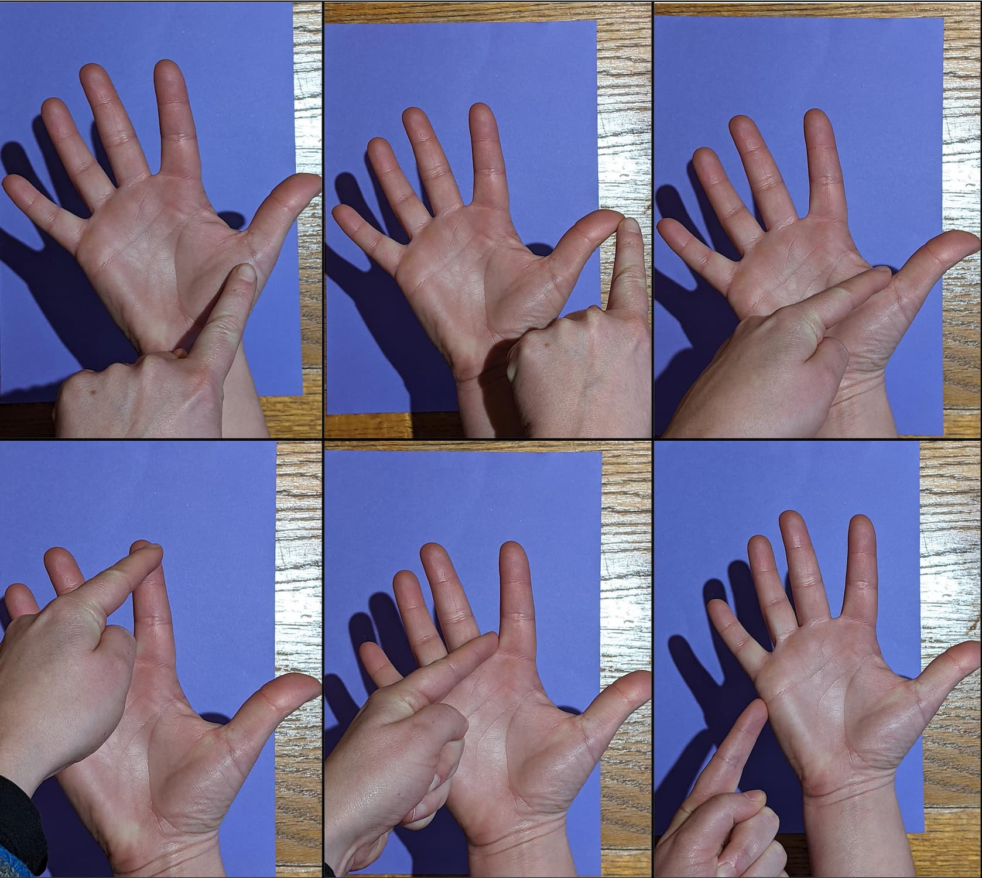
- Keep going until you have taken five big, slow breaths and have reached the end of your little finger.

