This activity has been designed as a starting point for looking, talking and doing together. The Look and Think activities should take 5 -10 minutes.
The Do activities might take longer depending on the task and how creative you are feeling!
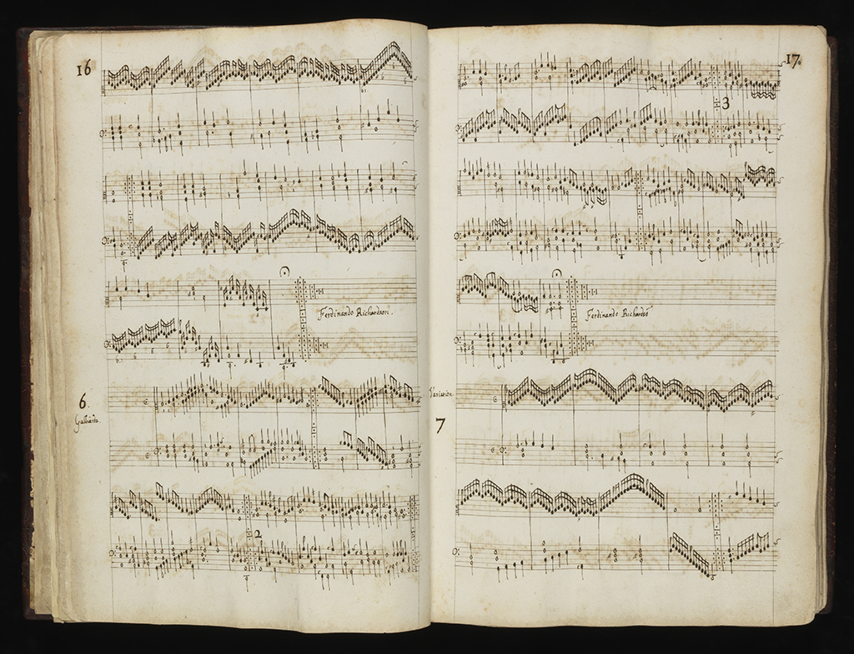
Look
Look carefully at this piece of music which can be played on a keyboard instrument called a virginal.
The patterns, shapes and marks make a musical score.

The Fitzwilliam Virginal Book
Think
Can you follow the notes up and down?
Where are the fast notes? And the slow notes?
Imagine how the music might sound.

London, early 17th century
Bequeathed by Viscount Fitzwilliam in 1816
Contains nearly 300 pieces for song and dance
MU.MS.168
Do
You can watch someone playing a virginal and listen to music from this book in this video.
Can you make up a dance to this music? Perhaps you could clap or stamp along with the beat?
Have a look on the next page for instructions to make your own musical instrument.

According to Suzanne Reynolds, Assistant Keeper in the Department of Manuscripts and Printed Books, this was once known as Queen Elizabeth I's Virginal Book. This volume is one of the most important treasures in the music collection bequeathed by Viscount Fitzwilliam (1745-1816), and is the richest anthology of sixteenth and early seventeenth century English Keyboard music in existence. The Fitzwilliam Virginal contains nearly three hundred works dating between 1562 and 1612. It represents thirty of the greatest composers of the time, including John Bull, Orlando Gibbons, and William Byrd. It was copied out by hand onto beautiful handmade paper, and the manuscript is still in its original binding of leather with gold decoration.
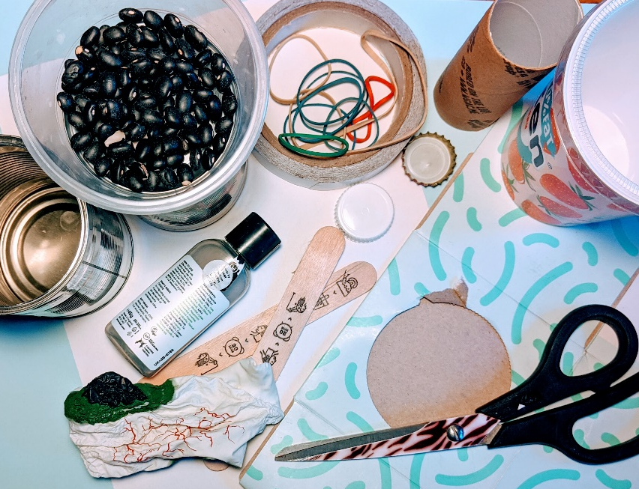
Do: Make your own musical instrument

You will need: dry beans or pasta, elastic bands, a balloon, sellotape, a clean empty tin and an empty container – maybe a clean old yoghurt pot or empty bottle.

For the drum:
- Stretch your balloon over the top of your clean tin and secure in place with elastic. Take care with the tin, they are sometimes sharp at the top.
- Try different things as drumsticks – your fingers, or lollypop sticks!

For the shaker:
- Fill your container with pasta, beans or lentils.
- Put the lid back on and sellotape it into place.
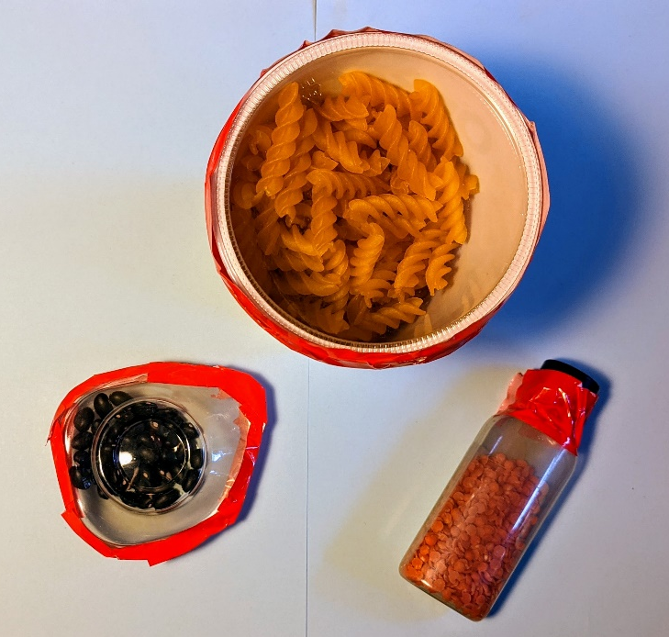
- Give it a shake and experiment with different sounds!

